MANUAL 1:
Overall ISC Approach for FWUC support

10/25/2011
ISC

Manual 1: Overall approach for FWUC & FO support
Contents
Presentation and objective of this manual: 3
Chapter 1: What is ISC? 4
Background of ISC and problem statement 4
Government policy for FWUC organization 4
Functions and limits of FWUC 5
GRET and CEDAC support for creating ISC 5
Vision 7
Mission 7
Objectives 7
Values 7
Governance 8
Economic model 9
Principles of ISC in supporting the FWUC 9
Ways forward 10
Working area and customers in 2009-2011 10
List of contracts (implemented and on-going) 10
FWUC networking: 11
Chapter 2: Service delivery for FWUC reinforcement 13
The service cycle 13
Domain of services 15
Adaptation of service to FWUC (arrow) 15
Chapter 3: How is ISC mobilizing resources? 16
Team organizational chart 16
Category of services and staff positions in service interaction 17
ISC relationship with customers and donors 18
Partners 19
ISC office and contacts 19

Presentation and objective of this manual:
This manual aims at providing basic information to the ISC staff and outsiders about the ISC organizational model and specific approach for supporting Farmer Water User Communities (FWUC) and other Farmer Organizations (FO). It introduces shortly the following manuals about the service cycle and various services.

Chapter 1: What is ISC?

Background of ISC and problem statement
The initial idea to develop the ISC came from two organizations, GRET and CEDAC, working as partners in the field of irrigation management in Cambodia. The lack of technical support available for the existing FWUC made them very fragile and the ISC has been developed to provide them access to the proper skills on a long term basis.

Government policy for FWUC organization
Since the end of the nineties, the Royal Government of Cambodia (RGC) has initiated a policy to extend irrigated agriculture as a mean to cover food security and to alleviate poverty in the country. This policy is translated into the construction of new infrastructures and the rehabilitation of old irrigation schemes with the financial and technical support of external donors.
The large majority of Cambodian farmers (80%) still depend on rainfed lowland rice cultivation during the monsoon season facing regular drought and floods events. According to some estimates, irrigation would be available only for about 20% of the country rice growing area. More 2,500 schemes are identified around the country, but actually, over half of these irrigation schemes are either not functioning at all or have a very low performance and infrastructures are in poor condition. Most schemes developed before the war have been destroyed or lacked maintenance, but this situation is also found in more recently rehabilitated schemes due to inappropriate initial designs, the lack of maintenance and a very low farmers’ involvement in irrigation management.
Since 1999, the Ministry of Water Resources and Meterology (MOWRAM) set up a policy called “Participatory Irrigation Management and Development” (PIMD) for setting up Farmer Water Users Communities (FWUC) and transferring to them the irrigation schemes management. The government objective is to ensure a higher sustainability of operation and maintenance for newly built or rehabilitated schemes. The Circular nº1 on “the Implementation Policy for sustainable Irrigation Systems” and the ministerial prakas nº306 which have been promulgated in 2000 provide the institutional basis on which FWUC can be created. It stipulates that FWUC are registered by the government as entities in charge of development, operation and maintenance of irrigation schemes in partnership with the government. It specifies as well that users have to cover the costs of operation and routine maintenance by themselves.
Nowadays there are 328 FWUC recorded. 114 of them are officially registered at MOWRAM level. Most of unregistered FWUC were created by the Provincial Departments of MOWRAM (PDOWRAM) in order to prepare rehabilitation plans and requests. Most of their committees are not working, do not collect Irrigation Service Fee (ISF) and rarely ensure basic maintenance. Up to now, due to a lack of human resources and financial means, PDOWRAM has not been able to sustain its support to FWUC further than the short-term process of their creation. In many cases further support is provided through external donors funded projects and is limited to project duration. At the end of the project implementation, FWUC have limited capacities and tools to ensure a sustainable management of their schemes and external support are ended.

Functions and limits of FWUC
The operation and maintenance of irrigation schemes require FWUC to undertake the following general functions:
- System operation, water management and sharing (setting up rules)
- Maintenance of infrastructures
- Irrigation Service Fee collection
- Administrative and financial management
- Institutional management (decision making, election, communication with members)
- External relations with other stakeholders
Looking into details, the proper implementation of these major functions requires a large variety of tasks and skills such as:
- Engineering, design, preparation of bidding documents, topographic survey, etc.
- Accounting, financial auditing, etc.
- Information database management
- Legal advise
- Contacting government, organizing meeting with local authorities
Depending on FWUC size and budget, not all of these functions can be learnt by the farmers and not all of them are required permanently. Where do FWUC can find support?
Depending on the scheme size, different organizational options could be proposed from the very small FWUC (village level) who may not need a very professional organization to the very large ones who will choose the option of professionalization, with more salaried staff, and will be able to internalize more specific functions thanks to scale economies. For example, Prey Nup PUC has its own accountant, manages a database of land owners and plots, has staff skilled to implement topography work, prepare bidding documents or monitor works, but still need to externalize functions such as auditing. In between, the limits between internalized and externalized functions have to be defined for each specific case.
For externalized functions, existing commercial service providers do not always provide ad hoc services and/or are not affordable for FWUCs (e.g. an annual audit of accounting and finance, provided by a local certified accountant company, cost from 1,000 to 4,000 USD).
From his side, PDOWRAM / FWUC department is mainly involved in the phase of creating FWUC, providing them with legal recognition and offering basic training in management. Its intervention is limited in time and scope. GRET and CEDAC conclusion was that there is room (and need) for the development of alternative service providers and to strengthen links between FWUCs and existing service providers.

GRET and CEDAC support for creating ISC
Since 1998, GRET and CEDAC were involved in two large irrigation schemes rehabilitated by MOWRAM: “Prey Nup” (10,500 ha) and “Stung Chinit” (2,500 ha) to support the management transfer to the farmers and users. In 2009, based on these previous experiences, they launched a new project named “ASIrri” to provide long term support to FWUC by setting up a pilot Service Centre in Kompong Thom province. What has become now the Irrigation Service Centre (ISC).
Why a Service Centre?
- To fill the gap when project support end.
- FWUC need external technical support from outside organization on the long run
- But no external organization is able to answer their practical needs at reasonable cost
- There is a need to built up knowledge and capacities and sustain human resources on the long run
- To enhance farmers ownership and make them become decision makers
- Services focus on demand
An important objective was to allow FWUC to access services which are:
  - Good quality, professional services,
  - Adapted to their particular needs and to their stage of development,
  - Affordable,
  - Sustainable
According to the scheme size and condition and the level of FWUC management different kind of service are required:
- For the less functional schemes, where no ISF is collected, the main objective is to enhance the quality of the irrigation service to the members and to guarantee a minimum level of resource for the FWUC in order to carry out its functions. Unregistered FWUC can be linked to PDOWRAM to get proper recognition.
- For the functional schemes where ISF collection and FWUC management capacities are insufficient to ensure the sustainability of operation and maintenance, the Service Centre focus on training FWUC on operation and maintenance and supporting ISF collection procedures and its financial management.
- To reduce running cost and gain from scale economies, several schemes can take benefit from sharing resources using the Service Centre skilled human resources. For example, one accountant or one technician from the Service Centre can bring support to several schemes on a permanent basis.
- For functions that are not needed permanently, but occasionally, FWUC can hire services on demand, for instance: financial audit, engineering services, works control.
The FWUC have to pay for the requested services, at least partially, but obviously additional financial resources are needed. The ISC has strong links with other institutions, agencies and professionals involved in the irrigation sector and can mobilize external capacities according to needs.
The ISC facilitates networking between FWUC and exchanges with government in order to bring field issues towards higher levels.

Vision
A pool of professionals, with a practical experience of irrigation management issues, provides affordable and quality services to FWUC and other FO.

Mission
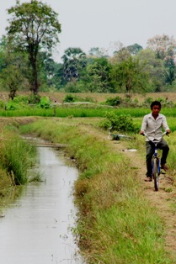
Support the collective management of FWUC and FO to ensure:
- the sustainable maintenance of irrigation schemes
- the efficient and fair sharing of water between users
- accountability and transparent financial management

Objectives
- To develop and implement professional services adapted to the particular needs of FWUC and FO.
- To strengthen links between concerned institutions, donors, professionals and farmer organizations involved in the water sector.

Values
  - Ensure its services are affordable for Farmer Organizations; Beneficiaries shall pay for the service costs.
  - Ensure the best quality of services possible and activities shall always be result oriented; Farmer Organizations shall evaluate activities and results;
  - Give priority to community and collective benefits over individual ones;
  - Promote respectful exchanges and equal relationships between all stakeholders whether farmers, technicians, engineers, any experts and civil servants;
  - Ensure a high level of transparency regarding its internal management and promote transparent management within Farmer Organizations.

Governance
The specificity of ISC organization is that its governance involves professionals from the irrigation sector and farmer representatives all together. The purpose is to ensure that a strong orientation towards farmer interests is maintained when developing the ISC strategy for service delivery and to try to ensure a good understanding between these groups.
The members of ISC General Assembly are from various origins:
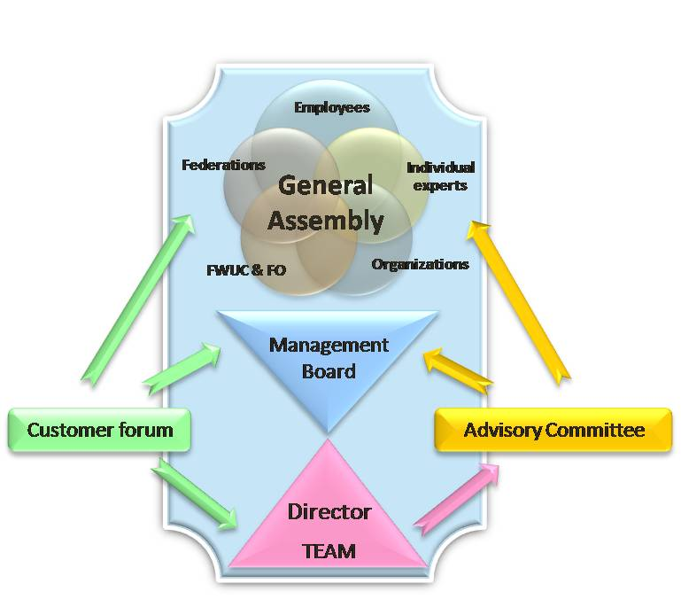
- The employees who have more than three months experience working with ISC,
- Other experts who are active in the sector and supporting the ISC approach, and might collaborate occasionally,
- Organizations who share the ISC objectives and develop collaborations,
- Selected FWUC & FO who have received services and who are familiar with the ISC work,
- Federation and network of FO.
Amongst each group, one representative is elected to the management board. Amongst them, one president and one vice- president are elected.
The management board recruits one director and a team to implement the daily work. Other experts, partner organizations, government agencies are invited to participate to the Advisory Committee to provide strategic advises and to facilitate linkages with other institutions. The Customer Forum brings together all ISC customers to discuss and share an evaluation about the services provided.
See statute and by laws of the ISC for more details
The first General Assembly and elections occurred on 13 and 14 October 2011.
The founding members of the ISC are 21:
- 13 employees
- 2 external experts
- 1 organization: CEDAC
- 4 FWUC: Prey Nup, Stung Chinit, Sdao Kong, Pram Kumpheak
- 1 federation: the Farmer & Water Net
The Management Board has been elected for three years: + photo
- President: Mr. Khim Sophanna (CEDAC representative)
- Vice-President: Mr. Tang Sophat (Expert)
- Ms Kan Sok Kanhnha (Employees’ representative)
- Ms. Rom Saroeun (FWUC representative, Stung Chinit)
- Mr. Nhem Sopheap (FWN representative, president of the FWUC of Pram Kumpheak)

Economic model
The ISC is a nonprofit organization who aims to get its main revenues from the Farmer Organizations who pay for these services. But this objective can be achieved only on the long term due to the current financial weaknesses of most FWUC and FO. So, at the moment, the current services are subsidized thanks to funding from projects and donors.
The ISC is also aiming at supporting FWUC to identify and get access to funds from donors and government to strengthen their organization and building their capacities.

Principles of ISC in supporting the FWUC
Three types of principles:
- Regarding the ISC itself
- Regarding the contracting process
- Regarding service delivery

- Start work with diagnosis / assessment
- Involve local people since the beginning
- Partnership:
- Services have been approved by PDOWRAM
- Collaboration with local authorities
- Screening / selection:
- Work with scheme : partly functional; economic potential; needs expressed by farmers and local authorities
- Work with FWUC which have at least 2/3 of members
- Work with FWUC which demonstrate commitment to cover OM costs
- Services are provided according to the needs
- Services according to actual functioning of FWUC and not according to theory / formal
- ISC works according to a service contract
- Users pay the service fee if the service is acceptable (Which service? Water service?)
- Investment fund for hard and soft
- Maintenance done according to priorities of the FWUC and to the resources (internal / external) available)
- Subsidy fund for the FWUC before ISF collection
- Comprehensive package
- Economic model and institutional model is a mix
- Service are evaluated by users at the end of the service
- Evaluation before service fee payment
- Monitoring of services and of FWUC: Evaluation of FWUC (33 indicators)
- FWUC networking and farmers’ organisation network
- Services to FO in general and not only to FWUC
- No ISF collection if no list of users.

Ways forward
- Build team capacity
- Achieve results on FWUC management improvement
- Defend the role of the FWUC in irrigation development
- Develop collaborations with more donors (but not any kind of collaboration)
- Strengthen ISC economy
- Strengthen ISC as an autonomous institution
for making the ISC a learning organization which can adapt to its environment!

Working area and customers in 2009-2011

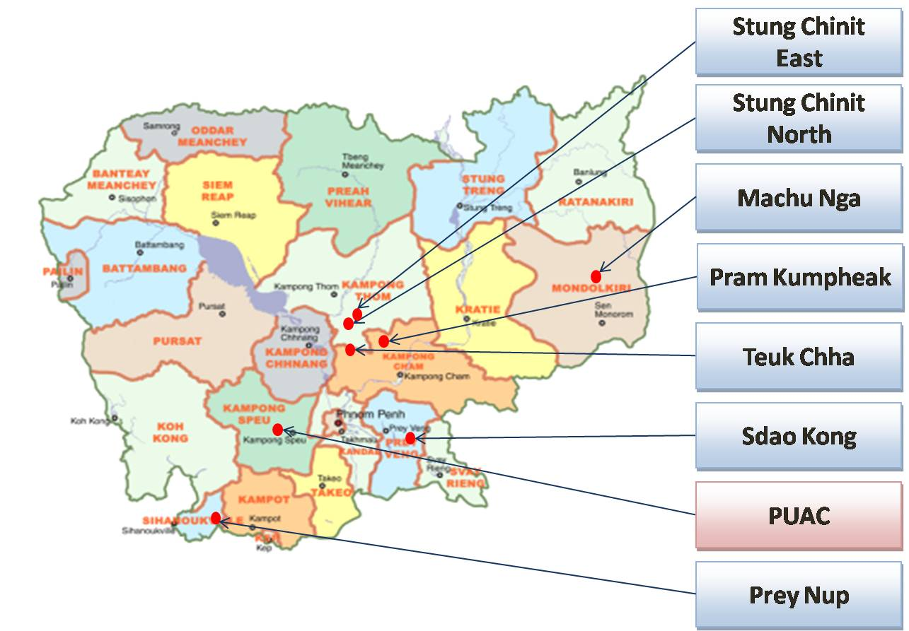

List of contracts (implemented and on-going)

FWUC networking:
The ISC created and supports the Farmer and Water Net for:
- Exchanging experiences between FWUC representatives
- Providing training and technical support to FWUC representatives
- Promoting FWUC leader responsibility, transparency and quality in FWUC and water management
- Bringing information to members (Legal documents, project and funding opportunities, procedures, etc.)
- Promoting the member needs to donors and government
- Facilitating relations with MOWRAM
- Advocating farmers and FWUC leaders opinions regarding irrigation and water management issues
- Representing members interests at national level and in irrigation forum
- Publishing policy papers related to members’ experiences and opinions

Localization of the members:
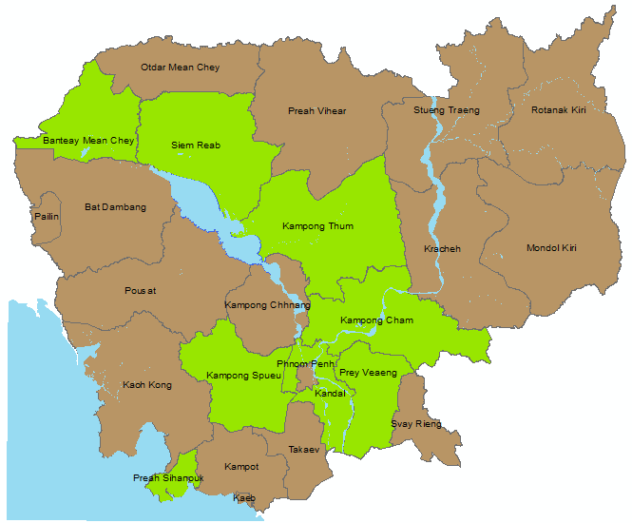
In 2011, the network involves:
- 12 FWUCs
- from 8 provinces
- about 206 villages
- ~20,000 farmers
- irrigated area over 23,000 ha

List of the members
 | FWUC name | Province | System | Scheme size (ha) WS / DS¹ | Number of farmers / members | Year of registra-tion | Level²
1 | Prey Nup | Preah Sihanouk | Polder | 10,492 / 0 | 6,385  (in 2006) | 2000 | V
2 | Sdao Kong | Prey Veng | Pumping station | 120 / 265 | 215 | 2004 | III
3 | O Treng | Kg Speu | Diversion | 1200 / 280 | ~1,000 | 2001 | III
4 | O Veng | Kg Speu | Reservoir | 514 / 100 | ~500 | 2003 | III
5 | Prek Ta Roat – Ta Ong | Kandal | Flood protection dike – Prek | ? / 321 | 529 | in process | III
6 | Kok Thnot | Kg Cham | Lake flood reservoir | 0 / 240 | ~100 | 2006  (district) | II
7 | Pram Kumpheak | Kg Cham | Reservoir | 492 / 50 | 719 | 2003 | I
8 | Teuk Chhar | Kg Cham | Reservoir | 4212 / 695 | 4,448 | 1999 | I
9 | Stung Chinit | Kg Thom | Major river diversion | 2400 / 300 | 2,804 | 2002 | IV
10 | Trov Kord | Siem Reap | Diversion | ~400 / 0 | 240 | in process | I
11 | Baray | Siem Reap | Reservoir | 1958 / ~1200 | 2,496 | 2003 | I
12 | Ponley | Banteay Meanchey | Reservoir | 400 / 100 | 438 | 2009 | II
¹ WS = Wet Season, DS = Dry Season
² FWUC management evaluation level (according to data in April 2011)

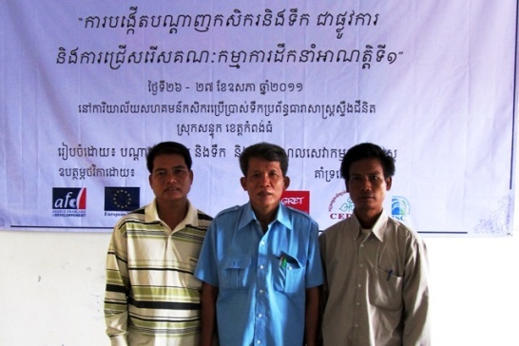
The 1st General Assembly was organized on 26-27 May 2011 and elected a Board of three members:
- President: Mr. Yim Boy (Prey Nup)
- Vice-president: Mr. Kung Sok (O Veng)
- Treasurer: Mr. Keam Bunrong (Stung Chinit)
The statutes are validated and under registration process with the Ministry of Interior.

Chapter 2: Service delivery for FWUC reinforcement

The service cycle

The ISC has developed a full process for contracting services in three phases:

Scheme identification and assessment
The purpose of this phase is to get clear information about new schemes where the ISC has never worked.
  - Short assessment and selection: the team collects data from the FWUC and local authorities and visits the scheme infrastructures in order to get a first look about its current condition. The information collected might be incomplete, but shall allow the team to get an idea if there is a possibility to provide support, to improve the scheme functioning or not.
  - Detailed study and mapping: if the scheme shows some potential for improvement and has been selected after the short assessment, the ISC team will collect data more systematically, visit all villages and draw the scheme on a sketch map with information about infrastructures, serviced area, problems, farmer proposals...
  - Intervention strategy design: the results of the detailed study are discussed within the team to design an overall approach to the future services: which steps shall be followed for improvement, which kind of supports shall be prioritized.
At the end of this phase, the ISC team will have enough knowledge about the irrigation system to be able to discuss a service proposal with the local stakeholders.

Service and contract negotiation
Before any support is provided, the ISC team must validate a service proposal and sign a contract with the local stakeholders.
- Study and strategy presentation: one or several meetings are organized with the FWUC representatives and the local authorities to present the results of the study and the general strategy proposed, so that there is an overall understanding and agreement on which supports are needed to improve the scheme management and a first step or service is prioritize.
- Formal service proposal: Based on the decisions made during the previous meeting, the ISC team prepares a detailed service proposal including all activities, expected outputs, staff mobilization plan and budget. This proposal is presented, discussed and approved by the FWUC representatives and / or the local authorities.
- PDOWRAM and local authorities’ approval: Before implementation, the FWUC representatives and the ISC team meet with PDOWRAM and other relevant government agents to inform about the work that will be done, to validate the service and get an official recognition of the ISC intervention, best up to district and provincial levels.
- Contract agreement: Once all has been approved, a service contract is written, including a budget and all parties’ responsibilities for implementation and payments.

Service implementation and monitoring
- Service implementation: After signing the contract, the team can be mobilized for the service. All activities have to be result oriented.
- Process follow-up: All meeting and inputs are recorded to ensure the proper implementation according to the service proposal and the number of working days on the contract for each staff is recorded.
- Service evaluation by farmers: Once the service is finalized, the outputs are evaluated and validated by the FWUC committee and presented to the farmers.
- Contract payment: If the evaluation is positive and approved, the ISC send an invoice and the FWUC pays the service.
At the end of one service, the ISC can propose a new service according either to the request from the FWUC or after a FWUC management evaluation.

See more explanations and tools in the MANUAL 2

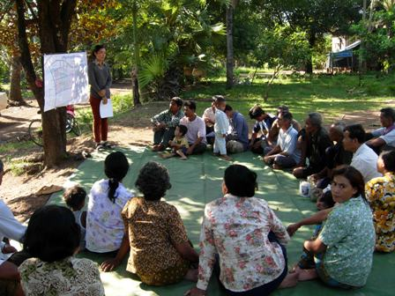
Domain of services
The ISC has defined nine domains of services to make FWUC able to fulfill all their functions:
- Institutional organization
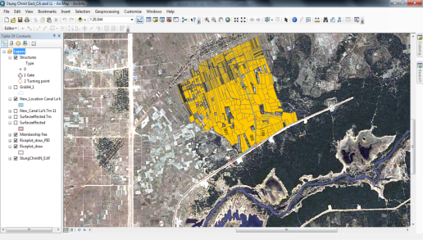
- Operation and water management
- Irrigation scheme improvement
- Maintenance planning and monitoring
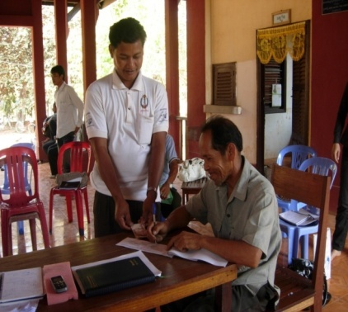
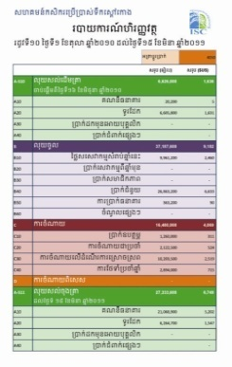
- FWUC database creation and update
- ISF collection
- Financial management
- Linkage between stakeholders
- Diagnosis & evaluation on FWUC management

Adaptation of service to FWUC (arrow)
The ISC has developed a participatory evaluation tool for the FWUC management based on 33 indicators. It allows assessing in detail with the FWUC representatives and their partners their capacities to fulfill the FWUC functions. The priorities to progress towards a higher level of management can be clearly identified and related services adapted to the FWUC current level proposed.
For example, a FWUC that is at level II, but fails to progress to level III due to their incapacity to collect ISF, a strong focus can be given to this criteria. However the assessment will probably shows as well, that they need to improve their budget estimate and the farmer database before going for collection. Or it might be also linked to a difficulty to communicate with farmers and support to develop communication tools and meeting facilitation would be a priority.
All these options are to be discussed in regards to the actual situation which may vary greatly from one FWUC to another. Two FWUC may require a similar service, such support to maintenance, but the service may be very different according to the actual infrastructure condition, the FWUC existing capacity and budget available to implement maintenance. The ISC may propose different type of service: training, coaching or direct implementation according to the needs.

The manuals
The various services and tools developed by ISC are presented in the following manuals:
Title |  | Description
Manual 1 | Overall FWUC approach for FWUC support
Manual 2 | The Service Cycle Management
Manual 3 | Creating and activating FWUC
Manual 4 | Organizing FWUC elections
Manual 5
Manual 6
Manual 7
Manual 8
Manual 9
Manual 10

Chapter 3: How is ISC mobilizing resources?

Team organizational chart
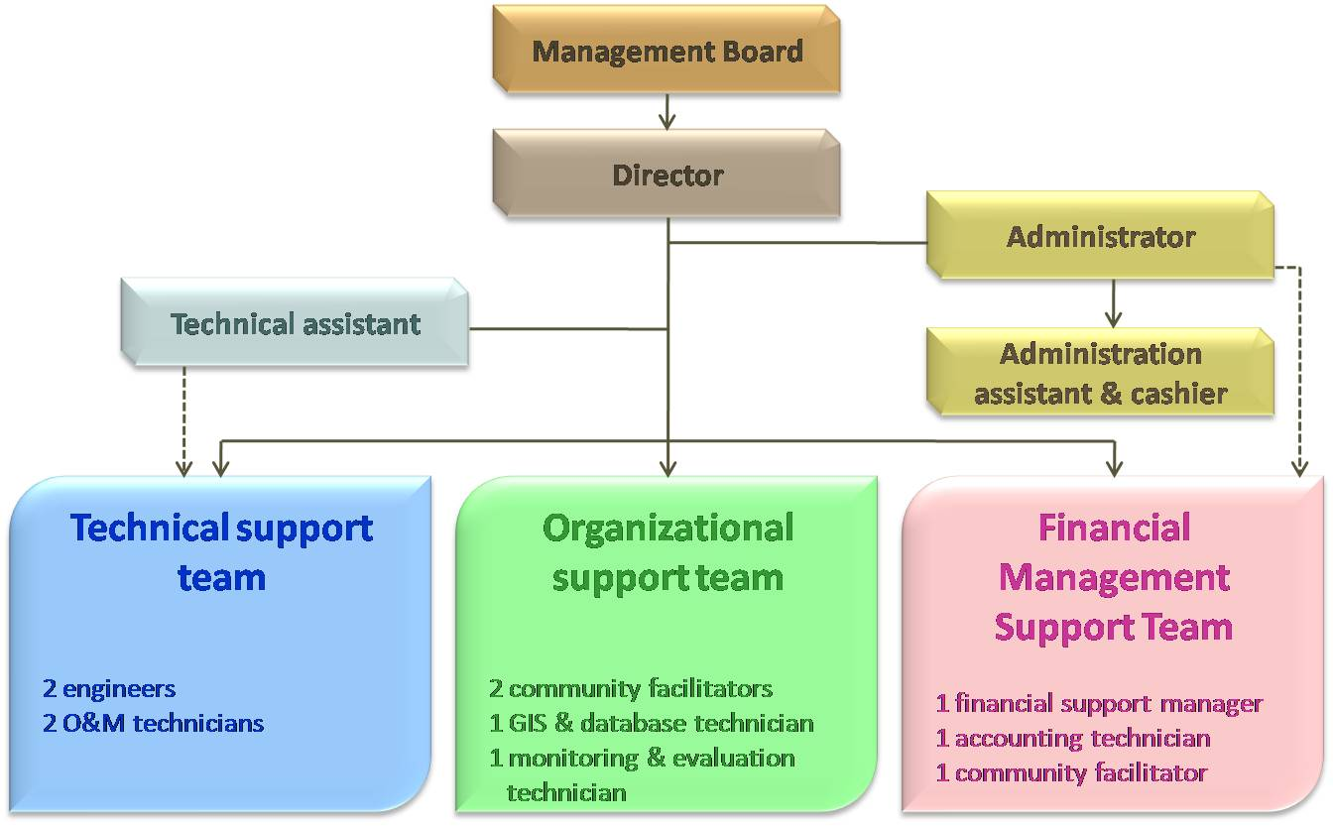
At the moment, the team is composed of 13 employees only: the ISC administrator and her assistant are also fulfilling the positions of financial support manager and accounting technician.
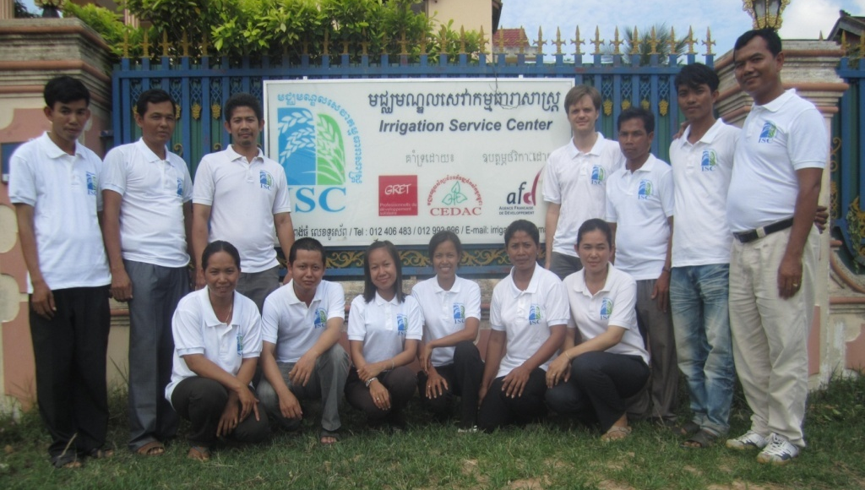
Most employees have been recruited locally in Kompong Thom province by GRET and CEDAC for the SCIRIP project since 2001. The facilitators and technicians have strong facilitation skills and knowledge about FWUC management. They built their experience over more than ten years. These local human resources are supported by engineers and agronomists who have a good practical field experience. The ISC will continue to promote local recruitments in the provinces close to the places ISC works over staff from Phnom Penh with higher education background, mainly for two reasons: to root the team in their working area over the long term and to build more trusted relationships between the professionals and the farmers. Such an orientation requires the ISC to provide invest on training and capacity building.
Other external human resources and consulting services may be occasionally contracted for specific purposes, especially if higher technical skills and knowledge are required, such as hydrology and infrastructures design, legal advisers, etc.

Category of services and staff positions in service interaction
In the frame work of service implementation, the ISC staff will occupy very different positions as trainers, advisers, technicians… They will take the full responsibility over the activities or build farmers capacity through formal trainings or coaching. Beforehand, the ISC team has to make assessment and develop tools. The progress requires regular monitoring and evaluation.
- Formal training for FWUC representatives
- Exchange visit facilitation
- Coaching for FWUC representatives:
  - Check farmer understanding through practice, learning by doing: meeting facilitation, gate operation and water management, maintenance, ISF collection, etc.
  - Provide advises on issues: budget planning, ISF level, water sharing rules, conflict solving, etc.
- Direct implementation by ISC staff:
  - Accounting
  - Financial reporting and control
  - Database creation and update
  - Infrastructures design
  - Maintenance costing
- Co-implementation of activities / project:
  - Bidding and contracting for construction
  - Maintenance and construction work supervision
  - Funding request preparation
  - Reporting to donors or partners
- Human resource allocation to FWUC (employment contract directly managed by ISC) such as: director, accountant, technician…
- Training to other organizations staff
- Assessment, monitoring and evaluation of scheme functioning and FWUC management (for ISC operation itself or for other project, organizations)
- Elaborating new tools for FWUC management: contracts, collection procedure, database, maps, accounting systems, statutes, internal rules, etc.

ISC relationship with customers and donors

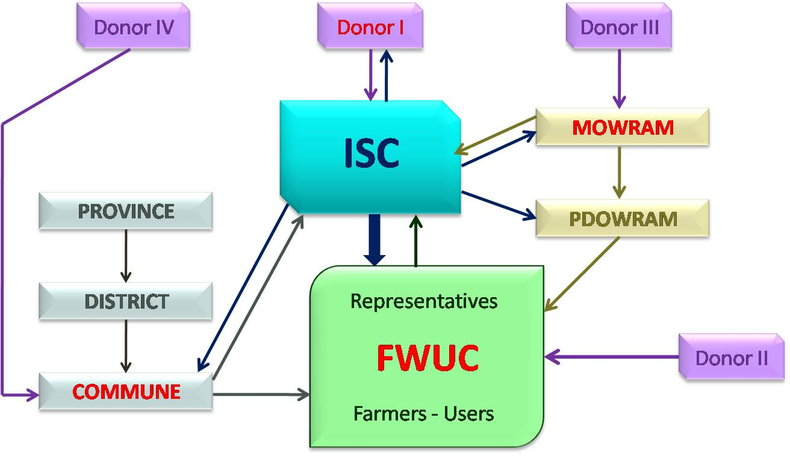
The ISC main objective is to sell services directly to FWUC and FO and to ask the FUWC to pay for the full costs incurred for service delivery. However due to the present financial weaknesses of the FWUC, the services are subsidized either through the ISC itself or indirectly from other sources:
- A donor can fund directly ISC to provide support to the FWUC
- The FWUC can get funds from other donors or from government (MOWRAM) and use it to contract ISC.
- The commune can use its Commune Development Fund to ask ISC services either to support the commune (for contract management, construction follow-up) or/and to provides services to the FWUC.
- The commune can access other external funding and use it for service payment.
- A project or an organization may require ISC services to strengthen its own team and methodology for supporting FWUC

Partners
Supporting organizations and partners
 | Groupe de Recherche et d’Echange Technologique | ASIrri project operator  French NGO
 | Centre d’Etude et de Développement Agricole Cambodgien | Cambodian NGO  ASIrri project partner  ISC founding member
MOWRAM | Ministry of Water Resource and Meteorology | Memorendum of Understanding for ASIrri project implementation

Funding sources in 2009-2012:
AFD funding for ASIrri Project: “Projet d’Appui aux Irrigants et aux Services pour les Irrigants Cambodge – Haïti – Mali (ASIrri)” (Jan 2009-Jun 2012)
EU Food Facility funding (Jan 2010-Jun 2011)

ADG
PUAC

ISC office and contacts

Circular #1, Appendix Part 2, Policy for sustainability of Operation and Maintenance of Irrigation Systems: "2.2 Transfer the management of the management responsibility and water allocation to the FWUC (a) Based on the capacity of the farmer organizations, the irrigation schemes shall be transferred to the FWUCs for their sustainable operation and maintenance and for the promotion of irrigated agriculture. Irrigation schemes not fully transferred shall be jointly managed by the FWUC and the government.
Stung Chinit Irrigation and Rural Infrastructures Project (2001-2009)

