|  |  |  |
| --- | --- | --- |
|  |  | ASIrri Activity Report No4  Component 1: Cambodia  July to December 2010 |

# Acronyms

ADB Asian Development Bank

ADG Aide au Développement Gembloux

AFD Agence Française de Développement

AVSF Agronomes et Vétérinaires Sans Frontières

CDF Commune Development Fund (fonds d’investissement communal mis à disposition par des bailleurs et l’Etat cambodgien via le NCDD)

CEDAC Centre d’Etude et de Développement Agricole Cambodgien

CSI Centre de Services aux Irrigants

CRIC Chinit Reservoir Irrigation Committee

CWPD Cambodian Women for Peace and Development (ADG local partner for PUAC)

D&D Decentralization and De-Concentration (Reforms)

ExCom Executive Committee of the Provincial Rural Development Committee

EU European Union

FAO Food and Agriculture Organization

FF Food Facility (funding or project)

FNN Farmers & Nature Net (Official network of the farmer associations created with CEDAC support in Cambodia)

FWN Farmers & Water Net

FWUC Farmer Water Users Community (Association des Usagers de l’Eau)

FWUG Farmer Water Users Group (subdivision of a FWUC)

IRC Institut des Régions Chaudes (Montpellier)

ISC Irrigation Service Centre

JICA Japan International Cooperation Agency

MoU Memorendum of Understanding

MOWRAM Ministry of Water Resources and Meteorology

NCDD National Committee for Sub-National Democratic Development (in charge of D&D reforms)

PDOWRAM Provincial Direction of Water Resources and Meteorology

PRDNEP Project of Capacity Development of Provincial Rural Development in Northeastern Provinces (finance par JICA)

PUAC Peri Urban Agricultural Center (Vegetable producer association supported by ADG)

PUC Prey Nup Polders Users Community

SCIRIP Stung Chinit Irrigation and Rural Infrastructures Project

# Main events for the third semester

One first Coordination Committee meeting was organized in August, it was a good opportunity to strengthen our links with local authorities and PDOWRAM. The key question coming up is the possibility to fund services thanks to the commune funds.

The construction and rehabilitation of 4 structures in 5 Kumpheak were properly carried out. Other support for institutional building went on as expected in Teuk Chha, Stung Chinit East and Machu Nga schemes.

During the period, one intern helped the team to develop water sharing principles and rules with the local communities, one intern helped to build financial management services and one Khmer student reviewed the experiences of coordination between FWUC, local authorities and government.

The ISC signed new contracts to support the financial management of Sdao Kong and Stung Chinit North FWUC. Unfortunately, the audit service proposed to Prey Nup PUC was rejected.

The main challenges for next 2 semesters are:

* Follow-up construction and maintenance works in Teuk Chha, Stung Chinit East and Sdao Kong schemes
* Strengthen the ISC team technical capacities for design, construction and maintenance follow-up
* Ensure the development of financial management services, also towards other kind of farmer organisations
* Define the ISC institutional model and register as a Cambodian organization
* Clarify the economic model for the ISC and identify new funding for 2012
* Build up the Farmer and Water Net, develop with its members quality standards for FWUC management and evaluation methods
* Organize a national workshop
* Participate to exchanges with other ASIrri project components

# Planned activities

For the fourth semester, the following activities had been planned according to the results of the third semester (see previous report):

Result 1:

* Recruit one staff for financial service management
* Purchase more GPS and one leveling tool
* Develop a website for the ISC
* Review the ISC economical model according to real expenses and service opportunities already developed
* One support mission from CEDAC
* One support mission from GRET – Paris
* One exchange visit from Mali to Cambodia
* One exchange visit from Cambodia to Mali

Result 2:

* 5 Kumpheak: finalize contract 2 and launch contract 3
* Teuk Chha: follow-up contracts implementation, carry out canal maintenance
* Stung Chinit East: finalized canal design and land compensation process
* Stung Chinit North: sign new yearly contract, detailed study for Banteay Yumreach
* Sdao Kong: sign a yearly contract for financial follow-up, prepare maintenance plan
* Machu Nga: Continue trainings, organize one exchange visit to Kompong Thom
* Baray detailed assessment
* Evaluate service provided and reassess support needs
* Clarify the procedure to mobilize CDF for services by communes

Result 3:

* 3 Internships implementation
* Prepare a second workshop (January – February 2011)

Result4:

* Organize the first Coordination Committee to review the first year of project implementation
* Organize one meeting and one exchange visit for the FWUC network members, register membership and create statutes

Result 5:

* Organize 2 management meetings

# Realized Activities

|  |  |
| --- | --- |
| **Activities according to Result 1 : A Service Centre for water users is created** | **Component 1 : Cambodia** |
| Investments for ISC | New equipments:  3 GPS, 1 computer for the Administrative Assistant  1 automatic level tool |
| ISC functioning | New recruitments:  One financial service manager  One engineer  End of contract: GIS engineer  1 management meeting organized on 28 October 2010  Nomination of Seng Sophak as ISC team coordinator |
| Technical Support missions to ISC | 1 support mission from GRET office in Paris |
| Training / workshop |  |
| Exchanges with other projects | 1 visit from ASIrri Mali team to Cambodia  1 visit to Mali for the ASIrri Cambodian team: Sophak, Piseth, Antoine |

**Team building / Human resources / Trainings / Staff exposures**

To accompany the internship and ensure the development of financial management services, one Financial Service Manager has been recruited in September 2010.

The GIS engineer had difficulties to manage its duty and it has been decided to terminate her contract. One young engineer has been recruited to help the construction and maintenance follow-up planned for next year. One community facilitator has now the capacity to manage the GIS tool even he would require some supplementary training.

**ISC investments and equipments**

New equipments have been purchased, mainly: 3 GPS, 1 new computer, 1 auto level tool.

**Institutional organization:**

One coordination meeting has been organized in August, 24 (see Result 4 below).

One management committee meeting between GRET and CEDAC representatives has been organized on October, 28 2010.

The main decision of the management committee meeting has been to review the progress made by Long Piseth in the position of ISC coordinator. After discussions, it has been approved by all the management committee to transfer this position to Seng Sophak starting on November. His job description has been reviewed with new responsibilities in the team management, activity planning and reporting, ISC representation and administrative management.

The TOR for a national expert mission about the ISC institutional building has been proposed to the management committee and validated. Consequently an announcement has been published, but no consultant replied. Being given the difficulty to identify local expertise on this subject it has been decided to progress on this issue with internal discussions. Two models are under review, one which includes service providers and customers within the governance and another one based on the team involvement within the governance. The next management meeting will have to specify which orientation will be followed.

**External Relations and Support Missions**

Patricia Toelen in charge of the project follow-up for GRET headquarter in Paris carried a support mission from 25 to 30th October. (Is there a mission report?)

One ISC staff (Kanhnha) and the intern on financial services attended a *“workshop on criteria method and financial support to farmer organizations”* in Kompong Som from November, 25 to 26. This workshop was organized by AVSF. An oral report has been made by Kanhnha to other ISC staff. It has been decided with the GRET monitoring and evaluation officer to work on this methodology with the ISC team on one or two FWUC has a basis to design a FWUC evaluation methodology in 2011. This workshop was also an opportunity to take contacts with many farmer organizations and federations. We plan to meet them individually in the next semester to present the ISC and consider their support requirements, especially regarding financial management.

The ISC has organized a coordination meeting with all the EU Food Facility project partners in Kompong Thom on December, 8. Representatives from EU, FAO and international and national NGO’s (Hellen Keller Int’l, ZOA, KBA, CDO, GTZ, AVSF, ADG, CEDAC and GRET) participated to this meeting. The ASIrri project was presented during this meeting which was followed by a field visit to Pram Kumpheak scheme where the ISC team could present the FWUC and explain about its strategy and methodology for supporting FWUC. This meeting was a remarkable opportunity to present the project and get contacts.

|  |  |
| --- | --- |
| **Activities according to Result 2: Farmer Water Users Communities are strengthened** | **Component 1 : Cambodia** |
| Investment Fund for FWUC | Improvement of 2 structures for 2,430 USD in 5 Kumpheak  Organized the contractor selection and contract signed for Teuk Chha maintenance for 39,610 USD (EU-FF fund)  Study the alignment for canal construction in Stung Chinit East |
| Technical Support mission for FWUC |  |
| ISC services to FWUC | Services implementation for 5 Kumpheak, Teuk Chha, Stung Chinit East, Machu Nga (Mundolkiri), Stung Chinit North,  New contracts signed with Sdao Kong and Stung Chinit North  Proposed service contract for financial audit to Prey Nup: refused and canceled  Service contract for PUAC signed and under implementation |
| Exchanges | 3 exchange visits: Teuk Chha and Pram Kumpheak to Stung Chinit, Machu Nga to Teuk Chha, Pram Kumpheak and Stung Chinit |

During this semester, the ISC team has been working mainly with 6 FWUC and one farmer organization.

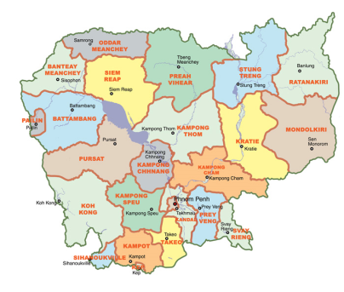

**PUAC**

**Sdao Kong**

**Teuk Chha**

**Pram Kumpheak**

**Machu Nga**

**Stung Chinit North**

**Stung Chinit East**

*Baray* (under study)

**List of contracts under implementation by ISC team**

|  |  |  |  |  |  |  |
| --- | --- | --- | --- | --- | --- | --- |
| Customer | Province | Scheme size  Ha | Service contract no | Date of signature | Service contract amount | Objective |
| FWUC Pram Kumpheak  Commune Lvea Leu | Kg Cham | 498 | 2 | April 22 | 8,000,000 riels | Database creation  Operation  Scheme improvement |
| ExCom Mundolkiri  PRDNEP-JICA  Commune of Royor  FWUC Machu Nga | Mundolkiri | 202 | 1 | March 5  May 17 | 20,000 USD (ExCom)  1,000,000 riels (commune) | Create a FWUC and provide training |
| Commune Kompong Thmor  FWUC Stung Chinit East | Kg Thom | 374 | 1 | May 4 | 6,900,000 riels (commune)  1,500,000 riels (FWUC) | Create a FWUG  Database creation  Study canal alignment & land compensation |
| FWUC Teuk Chha  Communes Kroch & Boeng Nay | Kg Cham | ~4,000  ~1,600 (Canal B) | 1 & 2 | May 4 | 1,400,000 riels (FWUC)  6,000,000 riels (communes) | Main canal operation  Create a FWUG on canal B  Scheme maintenance |
| FWUC Sdao Kong | Prey Veng | ~150 | 1 | October 1 | 250 USD | Financial management & other needs |
| CWPD / PUAC | Kg Speu | No | 1 | December 13 | 400 USD | Create financial management procedure manual |
| FWUC Stung Chinit North | Kg Thom | ~2,500 | 2 | December 24 | 280 USD (according to number of days worked for 20 USD/ day) | Financial follow-up & other needs |

**Pram Kumpheak Scheme (“5 February”) (Kompong Cham Province)**

The second service contract was signed in April 2010 with Lvea Leu commune and the FWUC for

1. Scheme improvement:

The construction of 4 structures has been finalized and paid. The design was made by a PDOWRAM engineer. The work has been contracted for 23,200 USD to a local contractor (funded by AFD).

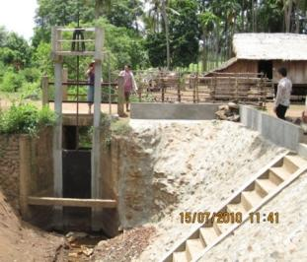

**Pram Kumpheak scheme map**

**(Lovea Leu commune):**

**Phum Bey Reservoir**

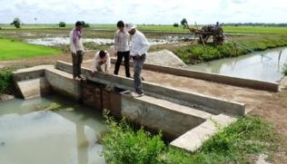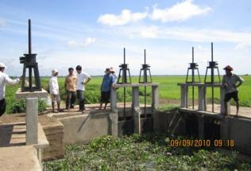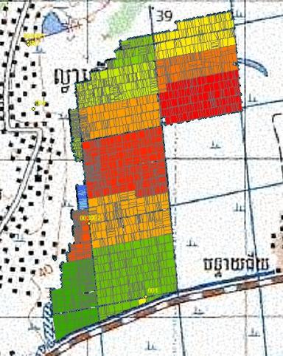

*Kbal Hong Chas check structure in 1ary canal*

*Trapeang Chrap three heads gate*

*Phum Bey water gate*

**Kbal Hong Chas Reservoir**

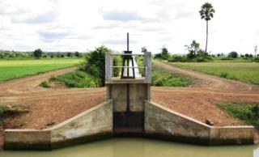

*Kbal Hong Chas water gate between 1ary & 2dary canal*

After the end of the work in July, some supplementary works were identified: the need to strengthen the Phum Bey water gate, to repair the bridge over the gate and protect the canal embankments from the water gate outflow and in Trapeang Chrap secondary canal to improve the 3 heads gate structure outflows. These works have been done in November 2011 by a local contractor for 2,430 USD (funded by EU-FF).

The total serviced area benefiting from these structures is 497.5 ha (GIS reference) for a total cost of 25,630 USD, this is an investment of 51 USD/ ha. 733 families cultivate this area. This rehabilitation and construction allow regulating the water and sharing it which was impossible previously. However these improvements are only partial, further canal rehabilitations should be organized. The commune is planning some future works.

1. Creation of a detailed plot database:

The database is finalized. There are only few crosschecks needed. All data, 4421 GPS waypoints and plots owner information, in the field have been collected. The initial number of landowners identified previously with the village leaders was 559. After creating the database, we could identify 733 different landowners for 2198 plots and a total area of 497.49 ha cultivated in the wet season. Within this area, 38.69 ha were cultivated in early wet season (double cropping) during the previous year. We expect that this double cropping area will be extended next year thanks to the scheme improvement.

Soon, this database will be provided to the FWUC and the payment of the second service will be requested. This database will allow the detail follow-up of irrigation and the ISF calculation and collection, hopefully next season.

1. Training on FWUC functioning, water sharing and system operational rules

A first draft of water sharing rules has been written together with the FWUG members. The ISC staff made a weekly follow-up of the irrigation during the cropping season from April to September in the field and during FWUG meetings organized to take decision on which area get irrigation according to which priorities. The rules will be reviewed according to experience.

All the FWUC/G representatives with the commune council members (13 participants) have participated to one exchange visits to the FWUC of Stung Chinit on December 10. They studied about the FWUC committee organization, the village meeting organization, the ISF collection process, the operation system for irrigation and other procedures.

Our next plan for a third contract is to work with the FWUC for the ISF collection and financial management after the next growing season, however all procedures should be finalized before the beginning of the coming season starting end of March for the early wet season rice. Before collecting the ISF, the FWUC may need some financial support for its normal functioning. The FWUC investment fund might be used for this purpose.

**Teuk Chha Scheme (Kompong Cham Province)**

In May 2010, two service contracts were signed between the ISC and the FWUC of Teuk Chha, Kroch and Boeng Nay communes in order to improve the water management along the main canal, to create a FWUG for the secondary canal B and implement the maintenance of the main canal and the secondary canal B with the development fund (EU-FF).

**Teuk Chha scheme map**

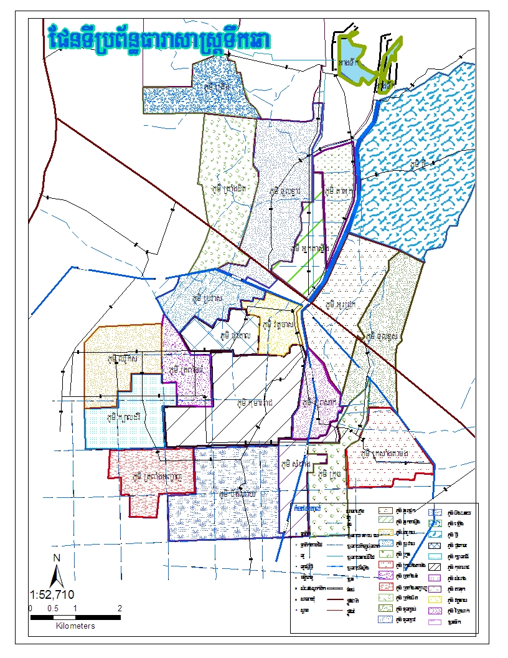

Thmar Da Reservoir

Teuk Chha Reservoir

~1500 ha

Canal C

Canal A

Canal B

Main Canal

1. Setting up operational and water sharing rules on the main canal

One intern arrived in June to support the team on this service implementation (see below Internships).

* An advisory committee has been set up in order to discuss and effectively take decision about new operational and water sharing rules. This committee is chaired by the PDOWRAM district staff, includes the 2 commune chiefs (respectively chief and vice-chief of the FWUC) and the concerned 24 village chiefs.
* 4 gate operators have been recruited and trained to ensure the water distribution during the rainy season. Their contract has been suspended in September due to less operation requirement.
* The main gate and secondary gates on the main canal received some repairs and where locked so that only gate operators are able to control them.
* Different water management rules have been proposed and tested. A system of formal request will continue to be tested next season.
* Meetings to inform and discuss with the farmers about the new management rules and water request system have been organized within 20 villages (922 participants).

1. Creating a FWUG on the secondary canal B

* A working group to devise the rules has been set up with all village chiefs.
* Village meetings to inform about membership registration and FWUG organisation have been organized within the 7 villages concerned with canal B irrigation.
* 609 farmers over 731 landowners identified (83%) have agreed to pay the membership fee.
* On October 26, the village representatives have been elected within the 7 villages. 568 members (93%) participated to the vote.
* On December 3, the chief and vice chief of the FWUG committee have been selected among 7 village representatives by a comment agreement between the representatives themselves.
* A bank account for the FWUG has been opened and the amount collected for membership fee registration (9,130,000 riels) deposited.
* All the Canal B FWUG representatives and concerned village chiefs (15 participants) have participated to one exchange visits to the FWUC of Stung Chinit on December 8. They studied about the FWUC committee organization, the village meeting organization, the ISF collection process, the operation system for irrigation and other procedures.

1. Main canal and 2dary canal B maintenance

* The maintenance needs (canal dredging and cleaning, infrastructures rehabilitation) have been estimated for a total budget of $40,000 by the ISC engineer.
* After an open bidding, a contractor has been selected in December and a contract has been awarded for 39,610 USD (funded by EU-FF). The works have started in January 2011 and are going on.

**Stung Chinit East Scheme (Kompong Thom Province)**

One contract with Kompong Thmor commune was signed on May 4 with ISC for

1. creating one FWUG in charge of the future irrigation system

* A working group to devise the rules has been set up;
* Information meetings about membership registration and FWUG organisation have been organized in 4 villages;
* 221 farmers over 289 landowners (76%) have paid the membership fee (total amount collected = 5,365,000 riels).
* On December 20, 3 village representatives have been elected to the FWUG committee by 172 members (78%).
* The FWUG has not yet its own bank account and the money his kept at commune level for the moment. The question is whether this farmer group want to become a specific FWUC or will be under the umbrella of Stung Chinit North FWUC. The farmers and the commune seem to wish to stay independent, but they would require an official recognition before opening a bank account. This point still need discussions.

1. creating a database with the detailed plot mapping

* All field data have been collected: 2556 GPS waypoints and the plot owners’ name;
* A detailed plot map of the command area has been drawn on ArcMap: 814 plots, 373.86 ha, 246 landowners. One area supposed to be within the command area was finally rejected so that the number of landowners is lower than the 289 considered above.
* Based on the database, 175 landowners (71%) became FWUG members and paid a total of 4,490,000 riels; 639 plots (78%, or 83% of the area) are belonging to FWUG members. Other FWUG members which do not have land in the reduced command area will be reimbursed.

1. supporting infrastructures design in collaboration with NCDD engineer from Kompong Thom Province

* The levelling surveys have been done for two possible canal alignments by ISC engineer together with NCDD provincial team.
* Accordingly different canal designs and cost estimates have been prepared and are under validation process by farmers, commune, NCDD and PDOWRAM.
* However the farmers have proposed a new canal alignment which was agreed on December 8. A new levelling survey is needed to finalize the design beginning of next year.

1. Study the future canal alignment and related land loss by farmers and possible compensation

* The team identified 49 landowners who will loose land for the canal construction. To simplify the process, it has been proposed as a principle to compensate this land loss with cash money at about 50% value of the land, as the farmers will also get easy access to irrigation. The exact amounts have still to be discussed according to the final design.
* The FWUC development fund might be mobilized for this land compensation, as neither the commune nor NCDD have budget for this purpose even if they agree on the legal need for it.

**Stung Chinit North FWUC (Kompong Thom Province)**

A second service contract has been signed with the FWUC of Stung Chinit North on December 24 for:

* financial management follow-up
* maintenance planning
* database update
* coordination and communication with local authority and PDOWRAM (CRIC meetings)

This contract will be implemented from January to end of April. After April, the MOWRAM subsidies will end and the FWUC is not sure to have enough financial resources to pay our services. The payment for this contract will be according to the number of days worked by ISC at a rate of 20 USD per day. The financial management follow-up would require 7 days and other works were estimated to 7 days (total = 280 USD).

During the internship on financial management, a new system of accounting follow-up on Excel software has been set up for the FWUC of Stung Chinit. It will be proposed and tested with the FWUC early next year.

Outside service contract, the ISC followed the third election process for the village representatives and the new management board. Our team was present during this crucial moment within the life of a farmer organization. It is the first election process that was fully managed by the FWUC itself outside the support of the SCIRIP project. The election was organized on November 18 in 25 villages. 1,736 members participated out of 2,678 (65%). 12 representatives are newly elected whereas 13 kept their previous mandate. Within the FWUC board 3 over 5 are new members. The president was not any more candidate to his position. He was replaced by a reelected member of the previous board. So, the continuity of the management is secured whereas there are significant changes within the board and representatives.

The ISC team attended and supported the organization of two CRIC meetings:

* On September 13 for preparing the FWUC representative election and discussing about a possible extension of the serviced area;
* On December 27 for presenting the election results, preparing the dry season cropping season and the ISF collection in 2011.

**Sdao Kong FWUC (Prey Veng Province)**

Following our assessment and the approval to provide a subsidy to the FWUC of Sdao Kong by MWORAM and AFD in May (6,300 USD) (see previous report), the ISC negotiated a service contract which was signed on October 1st for 250 USD. The objectives of the contract are:

* to train the committee about financial management principle
* to ensure the accounting follow-up
* to produce the seasonal financial report
* to support the ISF collection process
* to update the database and produce a plot map
* to facilitate general assembly meetings

2 support missions have been organized to Sdao Kong from November 2 to 6 and December 19 to 21. During these missions, the ISC team provided the following supports:

* one general meeting was organized to prepare the cropping season 10 (Nov 2010 to Feb 2011) and to agree on ISF price and irrigation calendar
* the annual budget plan for FWUC functioning in 2010-11 was prepared with the committee
* the FWUC committee received a first training on book keeping, expense follow-up, budget code definition and monthly financial follow-up
* Their bookkeeping records for the first months were reviewed.
* Some financial controls were made: cash box physical check, invoice and receipt control
* ISF collection process for 2011 was reviewed.

Besides this first contract, the ASIrri project proposed to use the FWUC development fund for maintenance of Sdao Kong schemes. These works still need to be estimated and are expected after the cropping season in March – April next year.

**Machu Nga scheme (Mundolkiri Province)**

In April a contract was signed between CEDAC representing the ISC and Excom Mundolkiri for creating a FWUC for Machu Nga scheme. This contract was funded by PRDNEP/JICA, but the ISC team as a whole funded by AFD has been involved for this contract implementation. For this work, the ISC got 20,000 USD as a fixed rate or package price. All expenses related to this contract (except salaries) have been used on this fund. The benefit is kept by the ISC to fund other activities in the future.

A service contract was also signed on May 17 with the Royor commune council for the creation of the FWUC. The amount of this contract is 1,000,000 riels. The contract is now finalized but the payment has not yet been done due to difficulties for the commune to access the fund for this purpose.

Between April and December, 10 field missions were organized to Mundolkiri to create one FWUC. The results of these missions are the following:

* A working group has been set up to follow the construction
* 33 members amongst 44 landowners (75%) paid a membership fee (660,000 riels)
* On May 20, 4 committee members were elected by 25 out of 33 members.
* A first general assembly was organized on May 28.
* The FWUC opened a bank account in June.
* On June 24, the FWUC was officially recognized at provincial level.
* A detailed map of the scheme was produced and the area of 44 plots were measured with ArcMap. The total command area is 202 ha.
* A database has been printed and provided to the FWUC committee.
* The FWUC committee received 5 trainings. These trainings were divided into several sessions. Training subjects:

1. FWUC organization and internal functioning: meeting facilitation, minute writing, leadership and trust building among community members, activity planning, responsibility sharing between FWUC committee and members,
2. Scheme operation: command area definition, expected service and responsibility sharing between members and committee for water distribution, difference of water availability identification within the scheme, cropping calendar for 2011
3. Construction follow-up: how the FWUC committee can monitor the construction activities by the private contractor.
4. Scheme maintenance: different types of maintenance, earth and concrete works, planning and budgeting.
5. Financial management, database and ISF collection: procedure to update the owner list and plots, budget for 2010-2011, procedures and tools for ISF collection

One exchange visit was organized from October 25 to 27 to Pram Kumpheak, Teuk Chha and Stung Chinit with 9 participants: 4 FWUC committee members, 1 village chief, 2 district officers, 1 PDOWRAM staff from Mondulkiri and 1 project staff from PRDNEP/JICA.

The construction work is achieved, but the scheme is not yet operational. Some supplementary works would be required. So, the ISC team is still available for accompanying the Machu Nga FWUC committee would they request it, but it is still under question whether the required supplementary works will be implemented or not in the future.

A final report has been written in English and Khmer and sent to JICA and Excom Mundolkiri in December.

**Prey Nup polders (Sihanouk Province)**

A service for auditing the accounts of the Prey Nup PUC was prepared by the ISC team with the support of the intern (see below). This service was already requested by PUC to ISC and GRET earlier. The team was ready to implement the audit, when, after long discussions, the PUC refused to sign the proposed service contract. In consequence, the audit service was canceled and abandoned. It would not be possible to re-launch it later because the team needs to be accompanied with an expert for this purpose. In consequence, there is no more service proposed to PUC at the moment.

We understood also that nearly no FWUC or other farmer organizations have a accounting system to allow auditing sufficiently developed to allow auditing; PUC is quite an exception. Our services should be oriented towards building financial procedures. Still control is an issue, but most farmer organizations do not want outsiders to control their account unless they are required to do so. Such service could potentially be developed through donors or projects supporting some farmer organization before their supports end or through federations as a quality requirement. Even if the need for control and support is obvious in most farmer organizations, the way to make them accept such control or even ask for it is problematic.

**Baray scheme (Siem Reap Province)**

The possibility to support the FWUC in Baray is still under consideration, but the ISC team had no time to implement the needed assessment up to now.

**Peri-Urban Agricultural Center - PUAC (Kompong Speu Province)**

The ISC is currently working at designing financial management services (see below internship). Within this framework, the ISC contacted different NGO and farmer associations to develop collaboration. The PUAC is a farmer association who purchase European vegetables produced by their members and sell them in Phnom Penh. This farmer cooperative is supported by ADG who is a partner with GRET for the EU-FF project. The ISC team visited several time the PUAC to study their financial system and assess their potential need for services. Two possible services were identified: reviewing the PUAC internal financial procedures and training their management staff on Quickbook software to improve their financial follow-up and reporting.

The first service has been designed in November and a service contract has been signed on December 13 with Cambodian Women for Peace and Development (CWPD) and ADG, the two organizations supporting the PUAC for a cost of 400 USD. This service aims at setting the financial procedures for PUAC management. A working agreement between ISC and PUAC was also signed on December 14.

One mission was done on December 13-14, and 20 in order to review the safe box management, purchase and sale procedures, bank cash flow and financial reporting. There will be two more missions next year and a final procedure book should be edited.

|  |  |
| --- | --- |
| **Activities according to Result 3: Technical and economic references are built up and capitalized** | **Component 1 : Cambodia** |
| Student Internship | Internship of one IRC student on services for water management  Internship of one student about designing financial management services  Internship of one Khmer IRC student about the coordination experiences between FWUC and other stakeholders |
| Technical and Economic Evaluation mission |  |
| Country Workshop (yearly) |  |
| Tri-countries workshop (yearly) |  |
| Final workshop |  |
| Publication per country and global |  |

**Student internships**

Three internships have been implemented

1. Fanny Lorgeron, IRC Master student – Montpellier (France)

Period: May to mid-September 2010

Subject: *“Designing services to reactivate farmer collective action in irrigation management in Cambodia”*

The student has made a study on two schemes: 5 Kumpheak and Teuk Chha. She worked on the ISC methodology to improve the operational management and water sharing rules for these 2 schemes. She has edited a thesis report both in English and French and will present her work at IRC in January.

1. Marion Duffieu, Bachelor of International Business, Reims Management School (France) & University of Technology of Sidney (Australia)

Period: Mid-August 2010 to mid-January 2011

Subject: *“Design financial management tools and procedures for Farmers Organization”*

The student has worked with two ISC staff to help them to design the following services:

* Audit service for Prey Nup PUC
* Financial management tools and procedures for Sdao Kong (2 trainings made)
* Accounting system follow-up on Excel for Sdao Kong and Stung Chinit (possible to use it for other FWUC
* Internal financial procedures for PUAC
* Quickbook tools for internal reports for PUAC

The intern also provided a Quickbook training for the ISC staff in charge of following the ISC accounting.

Farmer organizations collaborating with CEDAC and AVSF were also contacted and visited, but no support could be proposed at the moment.

A more detailed internship report is available.

1. Tang Sophat, IRC Master student – Montpellier (France)

Period: Mid-July to Mid-November 2010

Subject: *“Coordination systems between FWUC, local authorities and government services and/or private investor to ensure support to FWUC management and help in conflict resolution”*.

The case studies are Kbal Po, Po Pi Daem, O Treng and Teuk Chha schemes.

The field studies have been implemented, but the student faces difficulties for writing is internship report. The report will be produced early next year.

**Exchange visit between ASIrri components**

The ASIrri team from Mali visited the project in Cambodia from August, 15 to 23.

Three staff from Cambodia: Sophak (Institutional expert), Piseth (Technical expert) and Antoine Deligne (Coordinator) visited Mali project from November, 1 to 9.

See reports about these visits in the results of the component 4.

|  |  |
| --- | --- |
| **Activities according to Result 4:**  **National platforms for irrigation support and/or national coordination between water users’ organizations are provided with objective arguments and clear technical and economic references for advocacy.** | **Component 1 : Cambodia** |
| Exchanges with national farmers’ organizations platforms | One farmer network meeting in Phnom Penh on October 18-19 |
| Support to national level coordination (water users, sate, operators) | ASIrri project coordination meeting organized on August 24 |
| Position papers writing to launch advocacy activities |  |

**Coordination Meeting**

A first coordination meeting was organized on August 24 in Kompong Thom. The meeting was chaired by the director of Kompong Thom PDOWRAM and attended by the PDOWRAM director from Kompong Cham, NCDD provincial staff from Kompong Cham and Kompong Thom, AFD and JICA representatives, concerned district officers, CEDAC director and as well as the ISC management committee (GRET and CEDAC staff)

This coordination committee was an opportunity to present the ISC project progress and review its strategic orientation. Powerpoint presentations done during this meeting are available in English.

**FWUC Network**

The 3d FWUC network meeting was organized on October 18-19 in Phnom Penh. Two representatives from 11 FWUC (see the list in the previous report) participated to this important meeting (Teuk Chha representatives were the only absent). During these two days, the FWUC representatives drafted the network statutes and internal rules & regulations. They chose a new name for the network: Farmer & Water Net (FWN).

The new statutes are supposed to be validated by the committees of each FWUC. Each FWUC has to decide whether they will become a member of the FWN and write a membership request letter. After this process, the FWN could organize its first general assembly to adopt officially its statutes. Then the committee elections will be organized before submitting their statutes to the Ministry of Interior for the government official recognition in 2011.

# Activity follow-up and results according to logical framework

# Perspectives for the next 6 months

Result 1:

* Review the ISC economical model according to real expenses and service opportunities already developed
* Define the ISC governance model
* Register the ISC as a local NGO
* Look for future funding
* One support mission from CEDAC
* One support mission from GRET – Paris

Result 2:

* 5 Kumpheak: finalize contract 2 and launch contract 3
* Teuk Chha: finalize contracts implementation, carry out canal maintenance
* Stung Chinit East: finalize canal design and land compensation process, implement canal construction
* Stung Chinit North: implement the contract 2, negotiate 2011-12 subsidy with MOWRAM and communes
* Sdao Kong: financial follow-up, prepare maintenance plan and implement the maintenance
* Develop evaluation procedures
* Clarify the procedure to mobilize CDF for services by communes

Result 3:

* Prepare a second workshop

Result4:

* Organize one meeting and one exchange visit for the FWUC network members, register membership and create statutes

Result 5:

* Organize 2 management meetings

# Annexes

* Coordination committee meeting powerpoint presentations
* Activity report for the creation of the Machu Nga FWUC in Mundolkiri to ExCom and PRDNEP / JICA
* IRC thesis of Fanny Lorgeron in French and English languages
* Internship report of Marion Duffieux