|  |  |  |
| --- | --- | --- |
|  |  | ASIrri Activity Report No5  Component 1: Cambodia  January to June 2011 |

## Acronyms

ADB Asian Development Bank

ADG Aide au Développement Gembloux

AFD Agence Française de Développement

AVSF Agronomes et Vétérinaires Sans Frontières

CDF Commune Development Fund (fonds d’investissement communal mis à disposition par des bailleurs et l’Etat cambodgien via le NCDD)

CEDAC Centre d’Etude et de Développement Agricole Cambodgien

CSI Centre de Services aux Irrigants

CRIC Chinit Reservoir Irrigation Committee

CWPD Cambodian Women for Peace and Development (ADG local partner for PUAC)

D&D Decentralization and De-Concentration (Reforms)

ExCom Executive Committee of the Provincial Rural Development Committee

EU European Union

FAO Food and Agriculture Organization

FF Food Facility (funding or project)

FNN Farmers & Nature Net (Official network of the farmer associations created with CEDAC support in Cambodia)

FWN Farmers & Water Net

FWUC Farmer Water Users Community (Association des Usagers de l’Eau)

FWUG Farmer Water Users Group (subdivision of a FWUC)

IRC Institut des Régions Chaudes (Montpellier)

ISC Irrigation Service Centre

JICA Japan International Cooperation Agency

MoU Memorendum of Understanding

MOWRAM Ministry of Water Resources and Meteorology

NCDD National Committee for Sub-National Democratic Development (in charge of D&D reforms)

PDOWRAM Provincial Direction of Water Resources and Meteorology

PRDNEP Project of Capacity Development of Provincial Rural Development in Northeastern Provinces (finance par JICA)

PUAC Peri Urban Agricultural Center (Vegetable producer association supported by ADG)

PUC Prey Nup Polders Users Community

SCIRIP Stung Chinit Irrigation and Rural Infrastructures Project

## Main events for the fifth semester

* A **workshop about the ISC future institutional model** was organized on June 23 with all the ISC team and other stakeholders. Draft statutes and by-laws are still under discussion.
* A two weeks **training on maintenance planning and construction work monitoring** in Sdao Kong and Teuk Chha was provided to the ISC technical team (engineers & technicians), FWUC committee members and PDOWRAM staff in March.
* Several **construction and maintenance works** have been implemented or are on-going with the support of the FWUC investment fund (from EU-FF and AFD):
* Teuk Chha main canal and secondary canal B maintenance (39,610$, EU-FF)
* Sdao Kong pumping station maintenance (5,953$, EU-FF)
* Stung Chinit East canal construction (on-going, 97,014$, both EU-FF, AFD)
* Stung Chinit North maintenance works (on-going, 9,000$, AFD)
* The team has put in place **financial management services** such as:
* Simple budget and accounting system follow-up for Pram Kumpheak, Stung Chinit North
* Financial procedures for PUAC
* The ISC team has carried out a **participatory evaluation** of 12 FWUC who are FWN members, plus the FWUC of PoPiDaem (NWISP) according to the criteria methodology.
* The **first FWN general assembly** has been organized in May, the Statutes and membership of 12 FWUC approved and the management board elected.

The main challenges for next semester are:

* Finalize Stung Chinit East canal construction and land compensation
* Organize ISC first general assembly and register ISC as a Cambodian organization
* Finalize 6 training manuals for service implementation
* Organize a national workshop (end of the year)
* Identify new funding for the ISC to continue its support to FWUC during the year 2012

## Planned activities

For the fifth semester, the following activities had been planned according to the results of the fourth semester (see previous report):

Result 1:

* Review the ISC economical model according to real expenses and service opportunities already developed *(not done)*
* Define the ISC governance model *(Statutes to be finalized)*
* Register the ISC as a local NGO *(delayed to next semester after first GA)*
* Look for future funding *(not yet indentified)*
* One support mission from CEDAC *(on-going for training manual writing)*
* One support mission from GRET – Paris *(done)*

Result 2:

* 5 Kumpheak: finalize contract 2 *(done)* and launch contract 3 *(to be done soon)*
* Teuk Chha: finalize contracts implementation, carry out canal maintenance *(done)*
* Stung Chinit East: finalize canal design and land compensation process, implement canal construction *(on-going)*
* Stung Chinit North: implement the contract 2, negotiate 2011-12 subsidy with MOWRAM and communes *(done)*
* Sdao Kong: financial follow-up, prepare maintenance plan and implement the maintenance *(done)*
* Develop evaluation procedures *(done)*
* Clarify the procedure to mobilize CDF for services by communes *(not done)*

Result 3:

* Prepare a second workshop *(delayed to next semester)*

Result4:

* Organize one meeting and one exchange visit for the FWUC network members, register membership and create statutes *(done)*

Result 5:

* Organize 2 management meetings *(done)*

## Realized Activities

|  |  |
| --- | --- |
| **Activities according to Result 1 : A Service Centre for water users is created** | **Component 1 : Cambodia** |
| Investments for ISC | New equipments: 2 computers and one printer |
| ISC functioning | New recruitments:  One community facilitator (SCN FWUC director)  One administrative assistant  End of contract:  The technical expert  The financial service manager  3 project management meetings organized  Several meetings for the preparation of the ISC institutional model |
| Technical Support missions to ISC | 1 support mission from GRET office in Paris  2 CEDAC missions for writing manuals |
| Training / workshop | 1 training about maintenance by Eng. Vincent David  Trainings to ISC team about  FWUC management evaluation methodology  Quickbook accounting software  Access database  driving  1 workshop on the institutional model for ISC |
| Exchanges with other projects | ISC team coordinator participated to 2 MRC meetings in Laos and Thailand |

### ISC investments and equipments

New equipments have been purchased: 2 new computers for the new engineer and the new financial service manager and one color printer to publish maps.

### Team building / Human resources / Trainings / Staff exposures

* Mr. Long Piseth, the technical expert has resigned from his position end of March. No replacement has yet been found. The recruitment of one young engineer to fulfill the position of assistant to the ISC team coordinator is planned in July.
* The new Financial Service Manager stopped his contract in April 2011 for personal reason. No new recruitment has been launched. Ms. Kann Sok Kanhnha, the ISC administrative officer who was also involved in the financial services is taking over this position. To discharge her from administrative work, one administrative assistant has been recruited in April 2011.
* The director of the FWUC of Stung Chinit North has been recruited on April 1 by the ISC under a common agreement with the FWUC. He will become a facilitator for the ISC half-time and will be sub-contracted by the ISC to the FWUC half-time. This solution will reduce the costs for the FWUC budget and will strengthen the ISC human resource to provide support to other FWUC.
* A practical **training on maintenance planning and construction work monitoring** by M. Vincent David, an experienced hydraulic engineer has been provided to ISC engineers (2) and technicians (2), to FWUC committee (8) and to Pdowram staff (3) on two irrigation schemes:
* from 21 to 26 February 2011: maintenance planning for Sdao Kong scheme
* from 9 to 16 March 2011: construction work monitoring for Teuk Chha scheme
* Five ISC facilitators were trained on **FWUC management evaluation methodology** by the project coordinator on March 10 and 11, 2011. The proposed methodology was discussed and improved. This methodology was tested on 13 FWUC between March and May (see Farmer and Water Net below). After reviewing it, a presentation of this methodology has been prepared for a coming workshop organized by MOWRAM (see Annex).
* Several training and coaching sessions in May and June on **Quickbook accounting software** and financial control procedures have been provided by the project coordinator to the administrative officer (Ms. Kanhnha) and assistant (Ms. Many) and to the ISC team coordinator (Mr Sophak).

The ISC team is now able to manage a professional accounting system by themselves. The team still needs to write a clear financial procedure manual. These tools will ensure that the team will be able to follow the highest standard in financial management and reporting when the ISC will become an autonomous local organization.

* Mr Bunthoeun, the team GIS technician is following a **course on Access database** since June 2011 by a private teacher (on-going).
* In order to avoid recruiting a driver and ensuring the team mobility, two employees are following **driving courses** in May, June and continuing in July.
* The ISC Team Coordinator has participated to two Mekong River Commission (MRC) international meetings in Laos from March 1 to 5, and in Thailand from March 8 to 12. On this occasion, the participant was trained about graphic facilitation methodology.

### ISC institutional organization:

* **3 meetings of the ASIrri project management committee** (Cambodia component) with GRET and CEDAC representatives have been organized on January 11, April 22 and June 24, 2011. These management meetings have focused on the future ISC institutional model. Different options have been discussed between GRET and CEDAC.
* Two ISC staff meetings have been organized on January 11 and on June 2 to explain the purpose of the creation of ISC as a local NGO and the possible governance models.
* **One workshop** about the ISC institutional model and the first draft statutes was organized on June 23 in Kompong Thom with 19 participants from ISC (11), GRET (2), CEDAC (3), FWUC (2) and external experts (1). All these participants may become future members of the organization. Some decisions have been taken about:
* ISC organization mission, objectives and values
* Membership
* General Assembly organization & decision-making
* Management board members & decision-making
* President elections
* Role of the president, MB members and director
* Advisory board organization
* Etc.

Some other potential members or supporters from outside institutions (ADG, Jean-Marie Brun) have provided comments and insights, but could not manage to participate to the workshop. On the basis of all comments and ideas provided within and outside the workshop, a second draft version in English of the future statutes has been written and sent for further discussion. The draft statutes still need to be translated in Khmer. The first (foundation) general assembly for ISC is planned for end of September. The ISC registration to the ministry of interior will be done afterward, hopefully before the end of the year, depending on the release of the new NGO legislation which is still pending.

* The ISC internal accounting (not ASIrri project accounting) has been transferred from Excel software to Quickbook (see training above)
* The review of the ISC economical model has not yet been done – except from a tentative estimate of the ISC budget requirements for 2012 – for several reasons:
* The tools for following every service contract expenditures are not yet managed by the team; Developing internal accounting system is one step in this direction;
* The services are still in a design and development phase, it is difficult to estimate their individual costs;
* Our customers are not yet financially able to cover the service costs, far from it, so the ISC financial viability is not yet depending on service contracts payment; still for some more years, ISC will depend largely on donor and project supports.

For these various reasons, it seems rather early and complex to produce a business plan at this stage. It could be done in a second project phase, if new funding is identified.

### External Relations and Support Missions

* Patricia Toelen in charge of the project follow-up for GRET headquarter in Paris carried a support mission from 13 to 25 June. On that occasion, meetings and discussions were held with AFD, ADB, EU, GRET representation, CEDAC direction to review activity progresses and financial perspectives for ISC. (See mission report in Annex)
* 2 CEDAC trainers are implementing a support mission for writing training manuals. They visited the ISC team on May 9-12, and May 16-20 in order to study the ISC procedures for reactivating FWUC/FWUG. This mission will continue during the next semester (see below Publications).

|  |  |
| --- | --- |
| **Activities according to Result 2: Farmer Water Users Communities are strengthened** | **Component 1 : Cambodia** |
| Investment Fund for FWUC | Maintenance of Teuk Chha main canal and secondary canal B and related structures for 39,610$ (EU-FF fund)  Maintenance of the pumping station in Sdao Kong for 5,953$ (EU-FF fund)  Bidding, contracting and construction on going for Stung Chinit East canal construction for 97,014$ (including 10,000$ AFD funded)  Land compensation for Stung Chinit East canal construction  Support to Stung Chinit North maintenance budget for ~9,000$ (AFD) |
| Technical Support mission for FWUC | Consultancy for Stung Chinit East canal design and technical requirements writing (EU-FF)  Sdao Kong maintenance assessment by MOWRAM mechanic  Training for maintenance planning and construction work monitoring in Sdao Kong and Teuk Chha irrigation schemes for the ISC technicians and the FWUC committees |
| ISC services to FWUC | Services implementation for 5 Kumpheak, Teuk Chha, Stung Chinit East, Stung Chinit North, Sdao Kong  New contracts signed with Sdao Kong and Stung Chinit North  Service implementation for financial procedures manual for PUAC |
| Exchanges | Participation of FWUC and ISC staff to the FNN general Assembly |

During this semester, the ISC team has been working mainly with 5 FWUC and one farmer organization.

### Supported FWUC and FO location

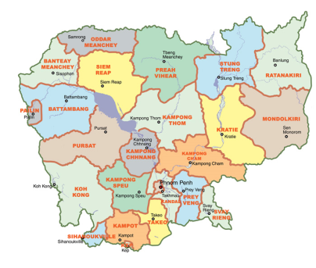

**Stung Chinit East**

**Stung Chinit North**

**Pram Kumpheak**

**Teuk Chha**

**Sdao Kong**

**PUAC**

### List of contracts under implementation by ISC team

|  |  |  |  |  |  |  |
| --- | --- | --- | --- | --- | --- | --- |
| Customer | Province | Scheme size  Ha | Service contract no | Date of signature | Service contract amount | Objective |
| FWUC Pram Kumpheak  Commune Lvea Leu | Kg Cham | 498 | 2  (not yet paid) | April 22, 2010 | 8,000,000 riels | Database creation  Operation  Scheme improvement |
| FWUC Pram Kumpheak  FWUG Kbal Hong Chas  FWUG Phum Bey | Kg Cham | 498 | 3  4 | Not yet | 1,940,000 riels  1,940,000 riels | Operation  ISF collection  Financial management |
| Commune Kompong Thmor  FWUC Stung Chinit East | Kg Thom | 374 | 1 | May 4, 2010 | 6,900,000 riels (commune)  1,500,000 riels (FWUC) | Create a FWUG  Database creation  Study canal alignment & land compensation |
| FWUC Teuk Chha  Communes Kroch & Boeng Nay | Kg Cham | ~4,000  ~1,300 (Canal B) | 1  (not yet paid)  2 | May 4, 2010 | 1,400,000 riels (FWUC)  6,000,000 riels (communes) | Main canal operation  Main canal maintenance  Create a FWUG on canal B  Canal B maintenance |
| FWUG canal B Teuk Chha | Kg Cham | ~1300 | 3  (under negociation) | June, 2011 | 4,360,000 riels | Canal B operation and maintenance  Financial management |
| FWUC Teuk Chha | Kg Cham | ~4000 | 4  (under negociation) | June, 2011 | 4,000,000 riels | Main canal & scheme operation & maintenance  Create a Reservoir Management Committee  Financial management |
| FWUC Sdao Kong | Prey Veng | 265 | 1 (paid)  2 (new)  3 (new) | October 1, 2010  April 27, 2011  April 27, 2011 | 250 USD  1,000,000 riels  5% ISF collected | Financial management & other needs season 10  Financial management season 11  Database & ISF collection |
| CWPD / PUAC | Kg Speu | No | 1 (paid) | December 13, 2010 | 400 USD | Create financial management procedure manual |
| FWUC Stung Chinit North | Kg Thom | 2,500 | 2 (paid)  3  (new) | December 24, 2010  April 1, 2011 | 280 USD (according to number of days worked for 20 USD/ day)  500,000 riels / month | Financial follow-up & other needs  Half-time recruitment of the Director & other supports |

### Pram Kumpheak Scheme (“5 February”) (Kompong Cham Province)

#### Service contract no2 implementation

The second service contract was signed in April 2010 with Lvea Leu commune and the FWUC for the creation of a detailed plot database. It was the first time for the team to implement this service and many technical difficulties had to be solved for the proper identification of the plots and their owners.

The database is now finalized and printed. There are only few crosschecks needed.

Final data:

* Number of plots: 2,198
* Number of landowners: 776
* Number of FWUG members (%age of land owners): 497 members (64%)
* Total area cultivated during the rainy season: 497.49 ha
* Total area cultivated for early wet season (double cropping) in 2011: 38.69 ha

In July, the final database will be provided to the FWUC and the payment of the second service will be requested. This database will be used for the follow-up of irrigation and the ISF calculation and collection (see contract no3).

#### Scheme improvement:

All construction works were achieved in November 2011, see previous reports.

#### Subsidies and service contract no3 & 4 under negotiation:

As the FWUGs are not yet collecting ISF, they have no resource for their functioning during the rainy season 2011. The project agreed to fund their functioning budget during this season. A funding agreement between the project and each FWUG is under negotiation. A first budget has been estimated and will be finalized early July. Total budget for 2 FWUG = 10,000,000 KHR.

Since March, the team is discussing the implementation of a third and a fourth contract for the following services:

* Technical support for operation, water sharing and maintenance during the wet season 2011;
* Support financial management and ISF collection at the end of 2011;
* Facilitate general assembly meeting organization.

The related service proposals have been written and submitted to each FWUG. The agreed cost for these services = 1,940,000 KHR for each FWUG. The funding sources for these services have not yet been identified.

### Teuk Chha Scheme (Kompong Cham Province)

#### Main canal and 2dary canal B maintenance

The maintenance of the main canal and the canal B have been implemented by a local construction company for 39,610 $US (EU-FF fund) between January and March 2011.

Summary of the works done:

|  |  |
| --- | --- |
| Works | Quantity |
| Outlet / gates maintenance and painting | 18 places |
| Outlet / gates / structures repaired | 44 places |
| New outlets and culverts constructions | 5 places |
| Main canal earth works (length = 5,069 m) | 5,539 m3 |
| Canal B earth works (length = 5,722 m) | 7,557 m3 |

**Teuk Chha scheme map**

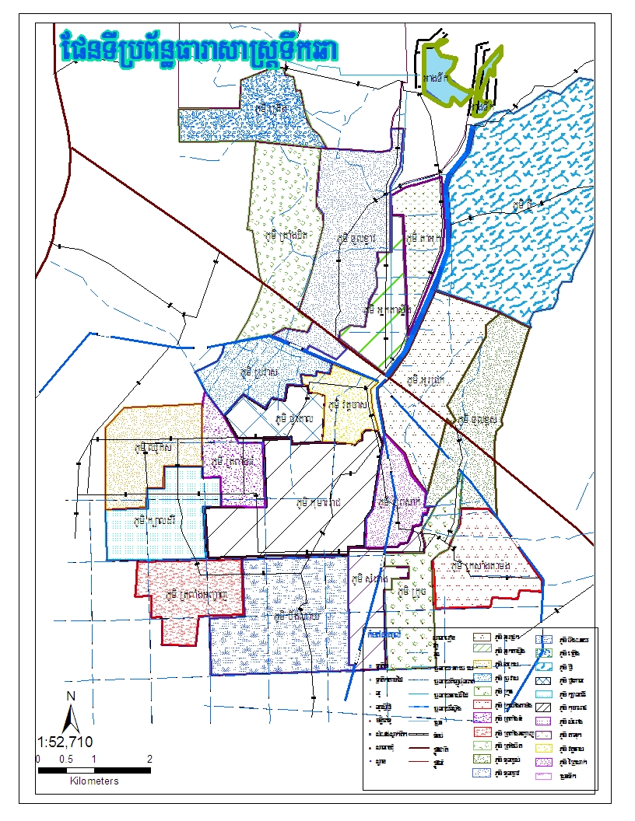

Thmar Da Reservoir

Teuk Chha Reservoir

~1500 ha

Canal C

Canal A

Canal B

Main Canal

*Canal maintenance with investment fund*

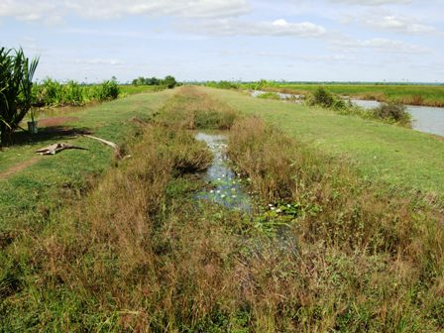 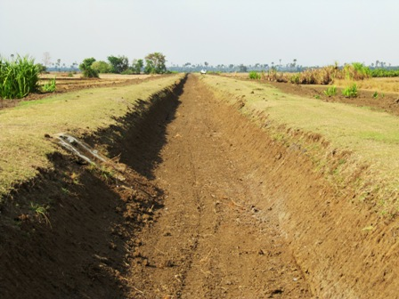

*End of secondary canal B after maintenance*

*End of secondary canal B before maintenance*

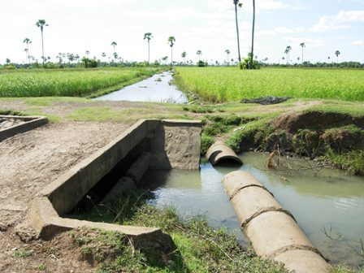 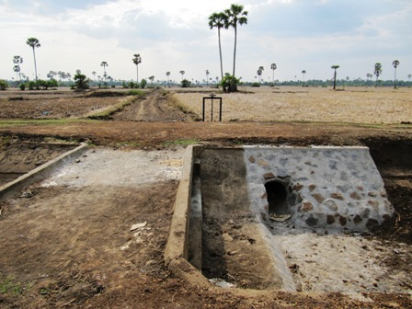

*Outlet on canal B before maintenance*

*Outlet on canal B after maintenance*

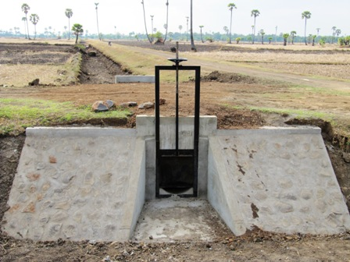

*New outlet on canal B*

These maintenance / rehabilitation works should benefit to:

FWUC as a whole:

* Number of families: 4,448 households (25 villages)
* Total area cultivated during the rainy season: ~4,000 ha

Secondary canal B:

* Number of families: 731 households (7 villages)
* Number of FWUG members : 609 members (83% households)
* Total area cultivated during the rainy season: ~1,300 ha

The detail data are not yet available as there is no reliable database available in Teuk Chha.

#### Service contract no1 & 2 implementation

The support for operation and water management of the scheme were ended at the end of the rainy season 2010. From January to end of March, the ISC engineers and technicians ensured the construction monitoring together with the two communes and the FWUC as co-project owners. During the maintenance works, no water was available for dry season cropping. Support for operation and maintenance shall be resumed during the rainy season 2011 (see contract no3 below).

The contract to establish a FWUG on the secondary canal B was finalized end of June with the organization of **seven village assemblies** from June 13 to 16. 287 villagers participated to the assemblies.

These assemblies discussed about:

* the FWUG future plans in term of operation and maintenance priorities;
* the ISF collection:

The FWUG decided to collect ISF after the coming rainy season, but on the condition that the farmers along the main canal also pay the ISF. The FWUC representatives agreed on this principle, but the methodology for ISF collection is still unclear, especially as there is no plot database and it is very difficult to identify which farmers get access to the irrigation water. The ISC is not in favour of starting ISF collection at this stage, but the farmers worry about their resources for next year.

* The FWUG budget proposed (see ‘subsidy’ below);
* The finalization of ISC service contract no2 and payment. This service still needs to be paid.
* The signature of a new service contract no3 with the FWUG only (see below)

#### Subsidies and new service contracts no3 & 4 negotiation

The FWUG and the FWUC of Teuk Chha are in the same situation like Pram Kumpheak as they are not collecting ISF yet, they have no financial resources for a normal functioning. The project agreed to provide a subsidy up to end of the year for their functioning according to a common agreed budget.

* Budget required for the FWUC: 16,000,000 KHR (~4,000$) including some small maintenance works.
* Budget required for the FWUG canal B: 18,500,000 KHR (~4,500$) including some small maintenance works.

(See budgets in annex)

These agreements shall be signed and implemented from July to December 2011.

In parallel the support from the ISC team should be provided according to new service contracts.

* The service proposal no3 with the FWUG canal B has been approved by the village assemblies and will include:
* FWUG financial management up to end of December
* Canal B operation and water sharing during the rainy season 2011
* Technical support for small maintenance works on secondary and tertiary canals

This service contract will be 4,360,000 KHR and shall be signed early July with the FWUG.

* The service proposal no4 with the FWUC is still under negotiation, it should include the following services:
* FWUC financial management up to end of December
* Overall scheme operation and water sharing between secondary canals during the rainy season
* Creation and facilitation of Reservoir Coordination Committee at district level
* Technical support for small maintenance works on primary and secondary canals (A&C)

This service contract shall be 4,000,000 KHR and shall be signed early July with FWUC and the communes depending on the payment for the first service.

No support for ISF collection has been proposed as we don’t think it is feasible and ISF will probably collected only next year.

The creation a **Reservoir Coordination Committee** is a special issue for the scheme operation. The provincial department of tourism is now managing the reservoir. It collects an entrance fee from the tourists and opens the gate to release a water flow for the tourists’ leisure. They are not considering the irrigation needs and there is no management of the reservoir level which is critical to be able to build an operation system. However creating such committee requires a decision at provincial level and the involvement of many different stakeholders at district and provincial levels: provincial departments of tourism, water resource and meteorology, fisheries, environment, district governor, commune chiefs and village chiefs (25).

The FWUC has no financial resources and no capacity to pay for these services. The communes might have the capacity to pay the services from the CDF, but it is not yet sure. They have first to pay for the contracts no1 & 2. The ISC team will follow with them this payment at provincial level.

### Stung Chinit East Scheme (Kompong Thom Province)

#### Service contract no1 implementation

This first contract signed with Kompong Thmor commune on May 4, 2010 is now finalized and should be paid soon. It includes several components:

* Creating one FWUG in charge of the future irrigation system

The FWUG was set up since last year, see previous reports. FWUG General Assembly has not yet been done, but will be organized next semester.

The FWUG of Stung Chinit East and the FWUC of Stung Chinit North have agreed to work together within the same official organization. The FWUG could open a bank account under the umbrella of the FWUC of Stung Chinit. The FWUG financial and technical management will stay independent, but may require time to time some support from the FWUC. A financial contribution from the FWUG to the FWUC could be considered according to these supports.

* Creating a database with the detailed plot mapping

The database was finalized, checked and printed. It will be provided soon to the FWUG.

Final data:

* Number of plots: 814
* Number of landowners: 246
* Number of FWUG members (%age of land owners): 175 (71%)
* Total area potentially cultivated during the rainy season: 373.83 ha
* Technical support for the canal construction (on-going, see below)

#### Canal construction

The construction of the canal of Stung Chinit East has been delayed, because the design and its alignment required more discussions with the farmers and engineers.

* Canal alignment and land compensation

The canal alignment has been discussed with the local authorities, the farmers and engineers several times before reaching a common agreement.

The project agreed to mobilize the FWUC investment fund (EU-FF) for compensating the land loss. The commune will own the future canal and will approve the land loss compensation on the condition that the farmers have official land titles. The PDOWRAM approved this process. Since the start of the construction the team is calculating exactly the individual compensations. The figures are now ready (land loss area=40.66a, 32 landowners and total amount =2,439,800 KHR (~610$US) and the project needs to edit invoices before the official payment in July.

* Canal design and costing

The canal is connected to an existing gate on the reservoir dam. And part of the canal was previously a canal built under Pol Pot regime, but was completely destroyed by the farmers who extended their fields.

The design of the canal has been sub-contracted to a local experienced engineer who worked previously on the Stung Chinit design. The engineer made the topographic study and estimated the construction costs. These designs have been approved by PDOWRAM. This engineer helped also to review the technical requirements for construction. The design does not include drainage system. The secondary canals will be developed in the future by the commune on the CDF fund.

*Stung Chinit East plot mapping and canal alignments* 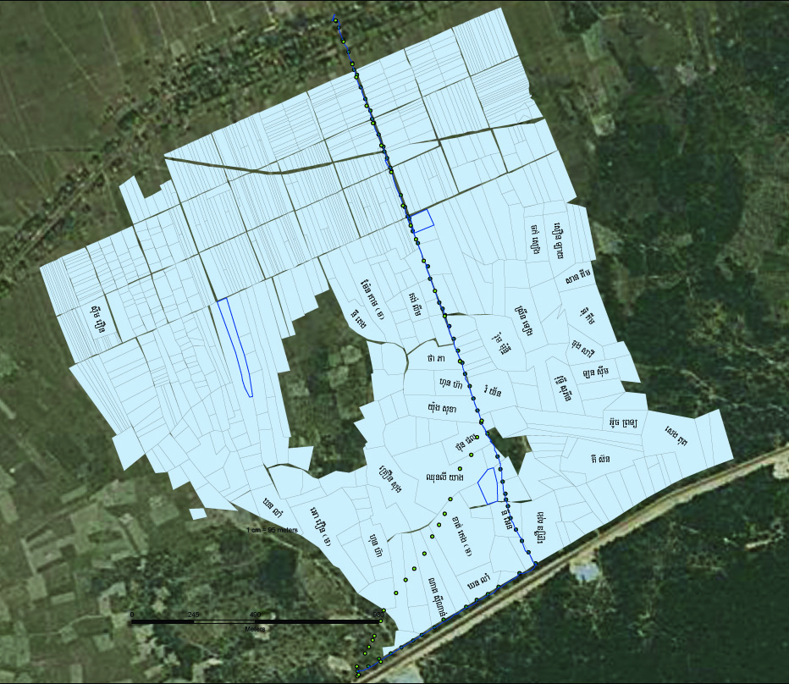

**La’ak village**

**Stung Chinit Reservoir**

*Alignment: First option*

*Second option*

*Final decision*

*Reservoir dike*

Summary of the construction works to be done:

|  |  |
| --- | --- |
| Works | Quantity |
| Main canal earth works (length = 2,850 m) | 28,935 m3 |
| Main gate outlet stone protection | 1 place |
| Embankment stone protection for canal turns | 2 places |
| Cart crossing bridge | 1 bridge |
| Check structure and outlets | 2 places |

* Bidding process and contracting

The project was approved during an official meeting of the commune council on April 9. The bidding process was launched in April by contacting some construction companies and displaying the bidding announcement in PDOWRAM, commune and district offices. The selection committee met on May 4. This committee was composed of the Kompong Thmor commune chief and councillors, the SCE FWUG president, the Stung Chinit FWUC president, the ISC team coordinator and the engineer, the coordinator of ASIrri project. Six companies made technical and financial offers. The contract was awarded for 90,604.80 $US on May 17 to Ponloeu Banteay Srey Construction Co. Ltd. and works started quickly.

A funding agreement between ASIrri project, the commune of Kompong Thmor and the FWUG was signed on May 17 for the same amount. The three parties are considered as co-project owners.

* Construction monitoring

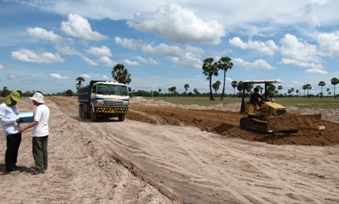

*Canal construction in Stung Chinit East*

A monitoring committee was established with ISC engineers and technicians, one FWUG representative and one commune councillor. Regular field visits are implemented and technical norms inspected.

On June 20, due to heavy rains, the company abandoned the works, and the contract was cancelled on June 22. The works done have been paid for 12,813.8 $US. After approval by the selection committee, the company in second position during the assessment was contracted for 84,200.25 $US (EU-FF fund and AFD ASIrri project) on July 1. The works are going on.

### Stung Chinit North FWUC (Kompong Thom Province)

#### Service contract no2 implementation

The second service contract signed with the FWUC of Stung Chinit North on December 24 was finalized end of March and paid 800,000 KHR to the ISC. The ISC team provided several supports:

* Calculating the maintenance budget and mapping all infrastructures
* Following ISF collection
* Organizing CRIC meetings
* Preparing the FWUC budget for 2011-12
* Writing the 2010-2011 financial report

#### Contract no3 for FWUC director

The FWUC director was recruited by ISC on April 1. He will be working half time for ISC and half time for the FWUC. The FWUC signed a service contract with ISC for making the director available on April 1 for 500,000 KHR / month.

Being given the uncertainties about FWUC funding sources for the year 2011-12, no new service contract was signed (see below).

#### Other activities (no contract)

The ISC continued to support the FWUC even though no new service contract was signed, especially to support the FWUC to formulate requests for subsidies from MOWRAM.

* Budget and subsidy requests to MOWRAM

The ISC team helped the FWUC to build a realistic maintenance and functioning budget for 2012 and following years according to the regular increase of ISF.

In March, the FWUC sent a request to MOWRAM for a subsidy of 80,000$ for the maintenance of secondary and tertiary infrastructures in 2011. On March 23, a field visit with MOWRAM and MEF co-chairmen of the maintenance fund committee did not bear the expected results. MOWRAM had already prepared a maintenance plan for secondary canals only without any consultation with the farmers. They were not even aware of the MoU for sharing responsibilities between MOWRAM and the FWUC. They could not modify their plans, but agreed on principle and orally that the FWUC could get some support on the next year budget.

In May, after several unfruitful informal discussions with PDOWRAM and MOWRAM, the FWUC sent an official letter to the minister requesting a subsidy for their functioning budget:

|  |  |  |
| --- | --- | --- |
| Year | ISF | MOWRAM subsidy |
| 2011-2012  2012-2013  2013-2014  2014-2015  2015-2016 | 50,000 KHR/ha  60,000 KHR/ha  70,000 KHR/ha  80,000 KHR/ha  90,000 KHR/ha | 80,000,000 KHR  60,000,000 KHR  40,000,000 KHR  -  - |

The FWUC committee agreed that the ISF shall increase further than 60,000 KHR/ha as planned to make the farmers able to cover the full budget by themselves on medium term. The FWUC could mobilize some provision previously accumulated, but would not be capable of reaching their objective, if MOWRAM is not providing subsidies during three more years.

The official answer has not yet been received. If the reply is negative, the FWUC may have to stop all activities by the end of this year or even earlier. They may be unable to collect the ISF next year making their plan unachievable. This situation would be very problematic as it is not sure how the FWUC could resume its activities later on.

* New accounting system on Excel

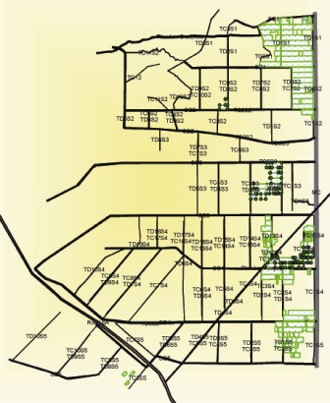The new system for Stung Chinit accounting follow-up on Excel software has been tested starting in April. The FWUC director and the ISC financial service manager have been trained for using this system. This new system is easier than the previous one and would facilitate the expenses follow-up and the production of regular reports.

* Follow-up of dry season cropping

During the dry season 2011 (Jan-May), the ISC team made a study to calculate the exact area cultivated and the yields according to practice in Stung Chinit North. According to a GPS study 207.7 ha were cultivated in rice and 2.8 ha with other crops. Part of this area was cultivated by farmers from other provinces renting the lands.

This year no important insect outbreak was observed. The yield estimated by interviewing and following 10 farmers were between 3 to 5 T/ha in 4 cases, between 2 and 3 T/ha in 5 cases and below 2 T/ha in one case.

*Dry season cropping area in SCN*

These results are rather encouraging, but for extending the dry season cropping area, local farmers have to intensify their practice like outsiders.

#### Maintenance works

The request for a maintenance fund subsidy to MOWRAM included emergency works critical the scheme operation during the rainy season. After MOWRAM refusal to fund even the minimal works required, the project decided to allocate 9,000 $US from the FWUC investment fund (AFD) for some maintenance works to be implemented at the beginning of the rainy season in order to ensure the irrigation during that season.

A funding agreement between the ASIrri project and the FWUC of Stung Chinit North has been signed on May 1. Most maintenance works have already been implemented and the FWUC is preparing a technical and financial report to claim for the project payment.

### Sdao Kong FWUC (Prey Veng Province)

Over the period 7 missions were implemented by the ISC team to Sdao Kong:

* February 8-10: training on financial management and accounting follow-up
* February 21-26: training by Vincent David about maintenance plan
* March 14-16: accounting follow-up, financial report for season 10, next season budget preparation, village assemblies preparation
* March 21-24: village assemblies organization
* March 28 - April 1: pump station maintenance and training on pump operation
* April 25-29: training on operation, data collection for database, contract negotiation, accounting follow-up
* June 14-17: GPS data collection for database, accounting follow-up

#### Service contract no1 implementation

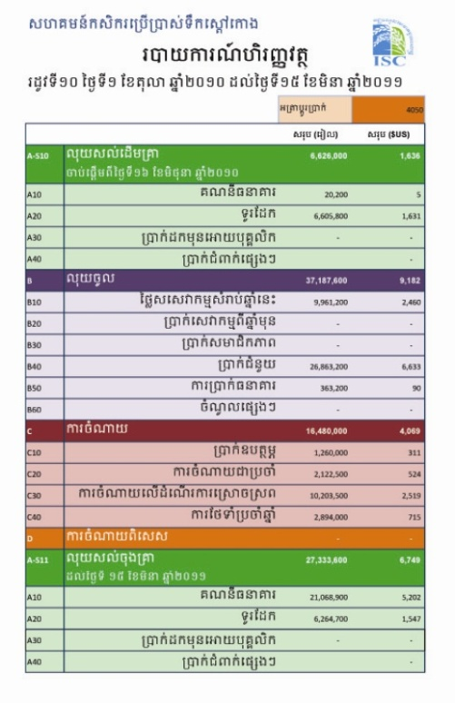

The ISC signed a service contract no1 was signed on October 1, 2010 for 250 USD. This contract was implemented up to early April and has been paid. The services implemented in Sdao Kong were:

1. Financial management service

The purpose of this service is

* to train the committee about financial management principles;
* to ensure the accounting follow-up;
* to produce the seasonal financial report.

The ISC team visited Sdao Kong two times to set up the accounting system, to follow-up expenses and produce the seasonal financial report. The financial report was finalized at the end of the season. A financial report was edited on March 16 and provided to the FWUC committee and to PDOWRAM of Prey Veng on March, 17.

The FWUC expenses during the season 10 (16,480,000 KHR) were higher than the ISF collected for this season (13,170,800 KHR), but the full MOWRAM subsidy (26,863,200 KHR) has not been spent. The FWUC real expenditures over the period were only 67% of the planned budget, because the pumping costs were lower than expected and because the maintenance works have not been done according to plans.

*Financial report (statement)*

1. Database and ISF collection service

The database has not been updated, but our team helped organizing village meeting and registering farmers who ask water for irrigation. The ISF collection was done according to this registration process. The ISC team controlled the results.

The FWUC has collected 13,170,800 KHR, 95% of the total ISF billed for 104.8 ha irrigated. The total amount billed was far from the expected ISF collection (33,600,000 KHR) due to the fact that most farmers got reductions of 50% and 75% if they have to pump from the main to the secondary canal or if they get water runoff from upland. The big issue in term of ISF collection is these high reduction levels and the fact that most farmers don’t register even though they get water and consequently are not billed.

These issues have been discussed with the committee at the end of the season and solutions proposed (higher ISF, lower reductions and irrigation follow-up at field level). The database will be updated with the next service contract.

1. Village assembly meeting

The ISC team has helped the FWUC to prepare a budget plan for the following season (March, 15 to August) and proposed to increase their ISF level to cover their full budget requirements.

On March 22-23, our team helped the FWUC committee to organize 4 village assembly meetings to present, discuss and approve:

* The financial report for the season 10
* The budget plan for season 11
* The new proposed ISF levels
* The motor pump maintenance
* The proposed services for the next season

The total numbers of participants of these meetings were 50.

#### Infrastructures & pump station maintenance

1. Maintenance plan

Vincent David, hydraulic engineer implemented a mission to Sdao Kong to prepare a maintenance plan (emergency, regular, yearly / seasonal, long term) together with ISC engineers and PDOWRAM staff. The mission purpose was both training and preparing the maintenance plan to be implemented during this year. However the team was informed that a Chinese company plans to destroy the main canal of Sdao Kong and rebuild it larger, we canceled our maintenance plans.

1. 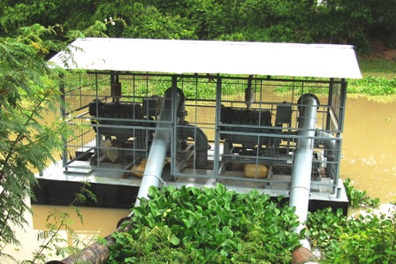Pump maintenance

Vincent David identified the pumps and their pontoon as the priority for maintenance. The FWUC had not made any maintenance other than changing oil over more than five years. So the project negotiated with the PDOWRAM and the Department of Irrigated Agriculture from MOWRAM to implement a full maintenance. The maintenance was done in Phnom Penh for 5,952 $US (EU-FF) before the beginning of the season 11.

*Sdao Kong motor pumps after maintenance*

The DIA mechanic trained the FWUC about the pump operation, the regular maintenance requirements and provided some spare parts (filters, etc.) to the FWUC.

#### Service contracts no2 & 3 for the season 11 (March – August 2011)

In April, the ISC has proposed two new services to the FWUC:

1. Accounting follow-up and financial report writing for the season 11

Service cost 1,000,000 KHR, contract signed on April 27.

Implementation is on-going; the accounting has been updated on June, 16.

1. Database creation and ISF collection for season 11

Service cost: 5% of the ISF collected, contract signed on April 27.

The GPS points have been collected and the database map edited. ISF collection will be implemented early August.

Current data:

* Number of plots: 410
* Number of landowners: 216
* Total area cultivated during season 10 (Oct-March): 104.8 ha

(according to ISF collection, largely underestimated)

* Total area cultivated during season 11 (April-August): 264.61 ha

(according to field measurements)

### Peri-Urban Agricultural Center - PUAC (Kompong Speu Province)

The team implemented several missions in order to understand the PUAC organization and rules (see previous report). ). On March 18, the ISC team presented the final draft procedures to the PUAC management board. The final version has been provided on April 8 to PUAC. The service cost (400 $US) has been paid to the ISC.

|  |  |
| --- | --- |
| **Activities according to Result 3: Technical and economic references are built up and capitalized** | **Component 1 : Cambodia** |
| Student Internship | Finalization of the internship of one student about designing financial management services |
| Technical and Economic Evaluation mission |  |
| Country Workshop (yearly) | Not done |
| Tri-countries workshop (yearly) |  |
| Final workshop |  |
| Publication per country and global | CEDAC technical missions for writing 5 training manuals about services |

### Student internship

The internship of Marion Duffieu, Bachelor of International Business, Reims Management School (France) & University of Technology of Sidney (Australia) was finalized mid-January.

Subject: *“Design financial management tools and procedures for Farmers Organization”*

A detailed internship report is available.

### National workshop

The team had discussed previously about the possibility to organize a workshop to present and discuss the financial management tools developed by the ISC. However these tools were not ready for presentation and more experienced in supporting FWUC financial management was needed. No other subject was found sufficiently mature for such event and workload of the team was too heavy for its organization. The project decided to cancel this plan and to prepare a final workshop to be organized at the end of the year were the subjects could be the funding for FWUC operation and maintenance and the financial management along other services developed by ISC.

### Publications

CEDAC has started implementing technical support missions for writing 5 training manuals about service implementation on the following subjects:

* Contracting services;
* FWUC organization / institutional building (up to first committee election);
* FWUC general management (meeting organization) (after first election);
* ISF collection (preparation, invoice edition) and rice plot database creation;
* FWUC financial management and budget;

One team is coming to ISC one week per month in order to collect information and discuss with the staff about their methodologies, tools and procedures. The first draft is expected for early July and all final versions shall be available for November.

|  |  |
| --- | --- |
| **Activities according to Result 4:**  **National platforms for irrigation support and/or national coordination between water users’ organizations are provided with objective arguments and clear technical and economic references for advocacy.** | **Component 1 : Cambodia** |
| Exchanges with national farmers’ organizations platforms | Participatory evaluation of all FWN members  FWN foundation general assembly on 26-27 May 2011 |
| Support to national level coordination (water users, sate, operators) |  |
| Position papers writing to launch advocacy activities |  |

### FWUC Network

#### Participatory evaluation of all members

All FWUC, FWN members have been visited by the ISC team to carry out an evaluation of their current management between March and May.

On these occasions, the final Statutes of FWN and the membership registration procedures were explained to the full FWUC committees (not only the representatives sent to FWN meetings).

Visits program for evaluations:

|  |  |  |
| --- | --- | --- |
| FWUC name (Province) | Date of evaluation | Category according to evaluation results |
| Trov Kord (SR) | March, 21 | I |
| Baray (SR) | March, 22 | I |
| Ponley (BMC) | March, 23 | II |
| Po Pi Daem (BMC)* | March, 24 | II |
| Pram Kumpheak (Kg Cham) | April, 5 | I |
| Prey Nup (Kg Som) | April, 19 | V |
| Stung Chinit (Kg Thom) | April, 22 | IV |
| Teuk Chha (Kg Cham) | April, 25-26 | I |
| Sdao Kong (Prey Veng) | April, 26 | III |
| Kok Thnot (Kg Cham) | April, 27 | II |
| Prek Ta Roat (Kandal) | April, 29 | III |
| O Veng (Kg Speu) | May, 10 | III |
| O Treng (Kg Speu) | May, 11 | III |

*Non-member of FWN

Example of evaluation result:

11-04-27 Kouk Thnot evaluationb.tif

#### FWN foundation general assembly

On May 26-27, the Farmer & Water Net hold their first (foundation) general assembly in the office of the FWUC of Stung Chinit with 24 FWUC representatives (2 representatives per FWUC: the FWUC president and another committee member).

On 26, morning, the FWN statutes were presented, discussed and the final version approved unanimously article by article.

On 26, afternoon, the evaluations of each FWUC were presented and discussed to determine for each FWUC, whether it can become a full member of the Network or only a learning member. FWUC can become full member only if they reach the category II. According to their evaluation, 4 FWUC became learning members and 8 full members.

After paying the membership fee, the membership was validated by the full assembly and candidates for the FWN board identified.

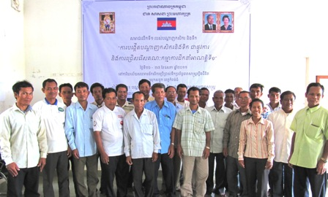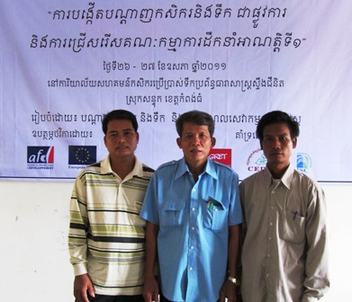

*Farmer & Water Net group photo during the 1st General Assembly The new elected board*

On May 27, the members elected one president, one vice-president and one treasurer amongst five candidates.

President: Mr. Yim Boy, president of Prey Nup was elected by 20/23 votes.

Vice-president: Mr. Kong Sok, president of O Veng was elected by 14 / 23 votes.

Treasurer: Mr. Keam Bunrong, president of Stung Chinit was elected by 13 / 23 votes.

After the election, a ceremony was organized with Buddhist monks’ prayers and official speeches. The officials who attended the ceremony are:

* One MOWRAM representative: the vice-director of FWUC Department
* The director of PDOWRAM in Kompong Thom
* The district governor
* GRET and CEDAC representatives

A press release was sent to the radio and journals in Khmer language. The event was broadcasted on television as well.

The FWN still need to get an official logo and to start registration at the Ministry of Interior. The project is waiting for the new legislation for association registration to be passed, before launching the registration process.

The management board shall meet in July to discuss about their future plans. A meeting with all members is planned for October in Prey Nup.

## Activity follow-up and results according to logical framework

## Perspectives for the next 6 months

Result 1:

Finalize the ISC statutes and by-laws

Organize the ISC first general assembly and the election of the ISC Management Board

Develop the ISC financial procedures manual

Develop the ISC strategy for 2012-13 and look for future funding

Continue the support mission from CEDAC for writing training manuals

One support mission from GRET – Paris

One support mission from IRAM (France)

Result 2:

5 Kumpheak: support the rainy season operation and maintenance and ISF collection (contract no3)

Teuk Chha: support the rainy season operation and maintenance and create the Reservoir Coordination Committee (contracts no 3&4)

Stung Chinit East: finalize canal construction and land loss compensation

Stung Chinit North: finalize maintenance and continue to support the search for subsidies

Sdao Kong: finalize database and support ISF collection for season 11

Follow-up service payments by the communes according to NCDD procedures

Result 3:

Finalize the 5 training manuals for service implementation

Organize the final national workshop

Result4:

Organize one last exchange visit for the FWUC network members

Result 5:

Organize two project management meetings

## Annexes

List of documents produced by the project during the period:

* Vincent David mission report, training materials and maintenance plans for Sdao Kong & Teuk Chha schemes
* Draft statutes of ISC (last version July 7)
* Management Board meeting minutes (February 11, April 22, June 24)
* MoU between ASIrri and FWUC / Communes for funding:
  + Teuk Chha scheme maintenance
  + Stung Chinit East canal construction
  + Sdao Kong pump maintenance
  + Stung Chinit North emergency maintenance
  + Teuk Chha FWUC and FWUG functioning budget June to December 2011
  + Pram Kumpheak functioning budget June to December 2011
* All service contract signed (see table above)
* Budget plans for Pram Kumpheak and Teuk Chha scheme (July to December 2011)
* Bidding documents and designs for Stung Chinit East canal construction
* Financial report 2010-11 for Stung Chinit North
* Accounting and budget plan for Stung Chinit North (Excel doc)
* Subsidy request for Stung Chinit North to MOWRAM
* Financial report for Sdao Kong season 10 (Excel doc)
* Financial report for Sdao Kong season 11 (up to end of June) (Excel doc)
* PUAC financial procedures (Powerpoints in English and Khmer, Word doc. in Khmer)
* Evaluations for 11 FWN members, plus Popidaem scheme
* Presentation of FWUC management evaluation methodology (Powerpoint, Khmer & English versions)
* Final statutes of FWN

Annex

* GRET - Paris support mission (June 13-25) report